

AIUB Sport Portal Management System
Course Name
ADVANCE DATABASE MANAGEMENT SYSTEM
Section: C
Group Members
Name | ID | Contribution
MD. Nashib Khan  (Project Lead) | 22-49873-3 | Introduction, Project proposal ,Scenario description, User Interface design, PL/SQL, Database design (25%)
MD Momen Sha | 24-56434-1 | Idea Generation, User Interface, Advance PL/SQL, Database design, Schema Diagram , Coding(frontend &backend) (25%)
MD. Al Amin | 22-48081-2 | ER Diagram, Normalization, Schema Diagram, Basic PL/SQL, Advance PL/SQL (25%)
MD. Sharif Iqbal | 22-49924-3 | Project proposal, Table Creation using SQL, Basic PL/SQL , Coding(frontend), Schema Diagram (25%)
Pranto Sen | 23-52029-2 | Introduction, Coding(Backend) ,Data Insertion Using SQL, Schema Diagram ,Conclusion . (25%)

Contents

Introduction 3
Project Proposal 3
User Interface Planning 4
Scenario Description 8
ER Diagram 9
Normalization 10
Schema Diagram 15
Table creation using SQL 16
Data Insertion Using SQL 21
Basic PL/SQL 26
Advance PL/SQL 36
Conclusion 50

Introduction:
The AIUB Sports Portal is a web-based platform designed to make sports activities at American International University–Bangladesh easier, faster, and more organized. Every semester, many students participate in tournaments, but registration is usually manual, time-consuming, and difficult to manage. This project solves that problem by creating a digital system where students can log in with their official AIUB accounts, complete their profiles, view ongoing tournaments, and register for games. Admins can also create tournaments, manage participants, and handle all sports-related tasks from one place. In simple terms, the portal brings the entire sports management process online so both students and AIUB authorities can save time and reduce mistakes.
Project Proposal:
This project proposes the development of a complete sports management web portal for AIUB that integrates authentication, tournament management, and game registration within a secure and intuitive interface. The goal is to eliminate the traditional paperwork-based registration system and replace it with a reliable digital system that ensures accuracy, safety, and real-time data handling. The portal will allow students to log in using Microsoft Azure Active Directory, which guarantees identity verification and restricts access only to authentic AIUB students. Once logged in, students can complete their profiles, view ongoing tournaments, and register for specific sports categories. Administrators will be provided with a dedicated dashboard where they can create tournaments, upload tournament images, set registration deadlines, add game categories, and manage participants. To maintain fairness and data accuracy, the system includes several important business rules, such as limiting the number of name edits, locking sensitive profile fields after initial setup, and enforcing registration deadlines. The proposal supports scalable architecture built with Node.js, Express.js, Oracle Database (10g), and pure HTML/CSS/JavaScript on the frontend. The platform ensures secure communication, strict input validation, and structured database design. By integrating PL/SQL stored procedures, triggers, and sequences, the system achieves high data integrity and reliable automation. Overall, the AIUB Sports Portal aims to provide AIUB students and admins with professional, automated, transparent, and trustworthy sports management experience.

User Interface Planning:


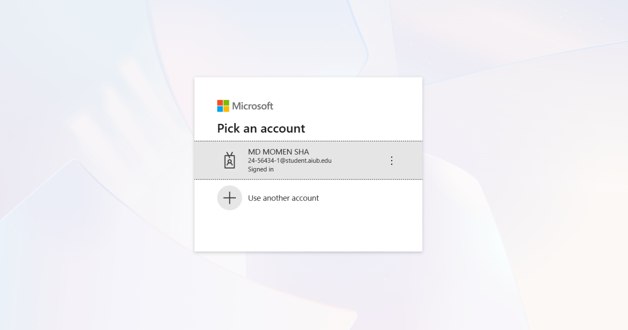
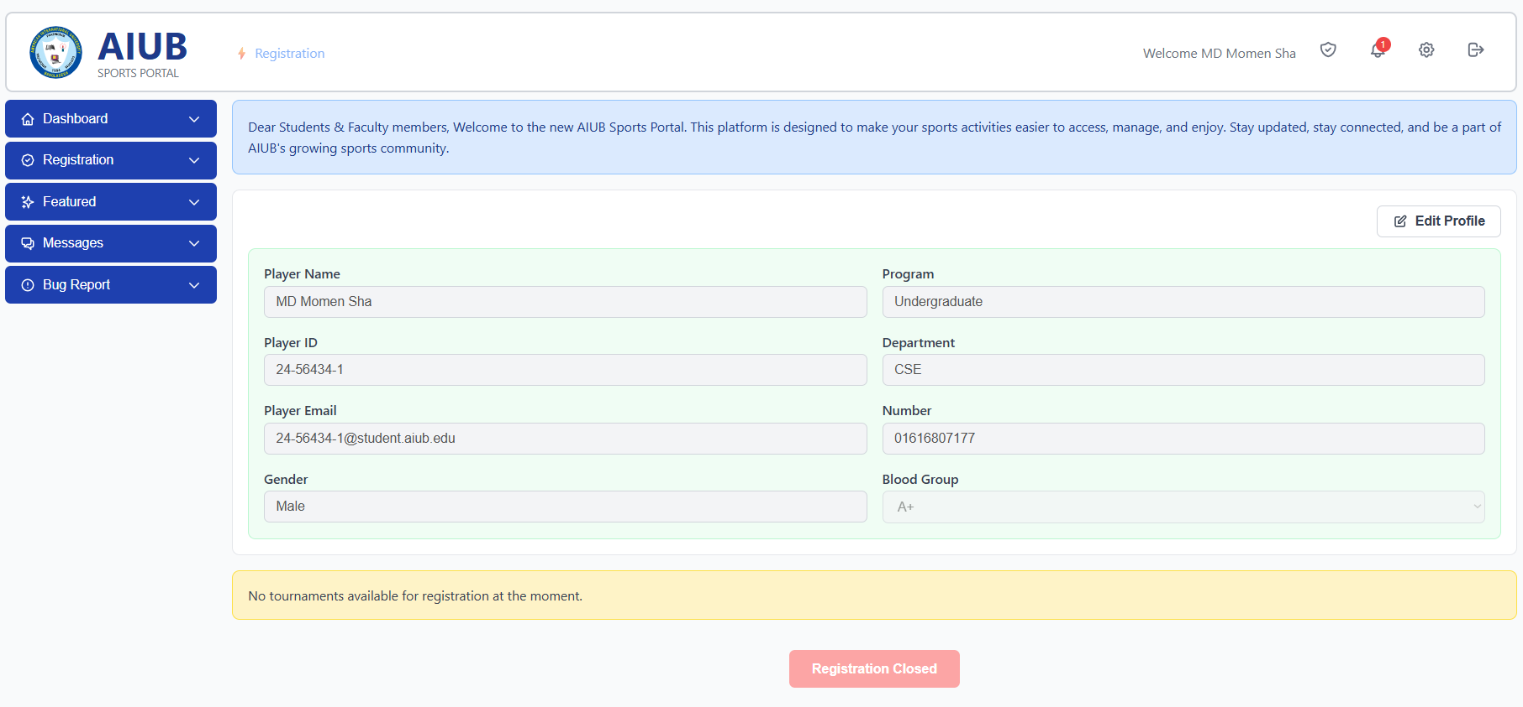

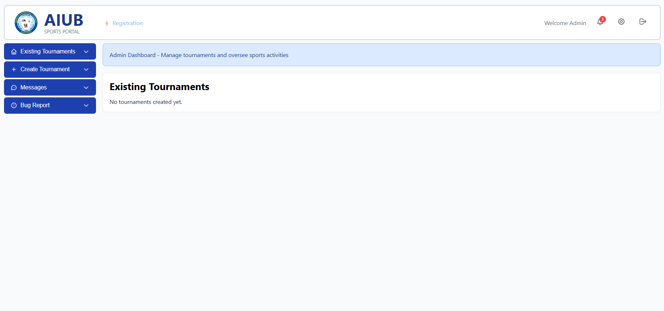

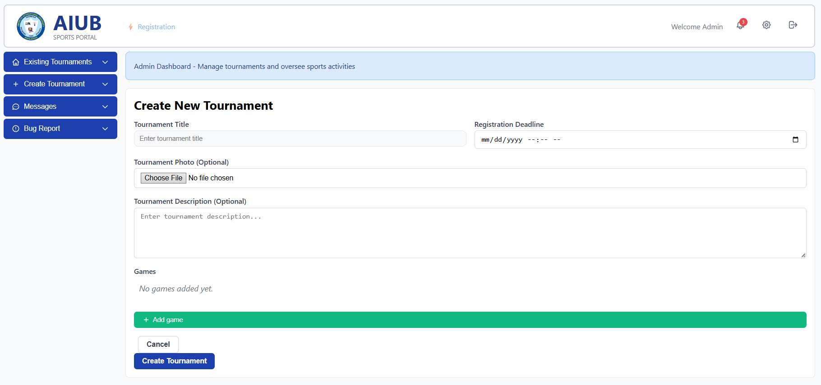

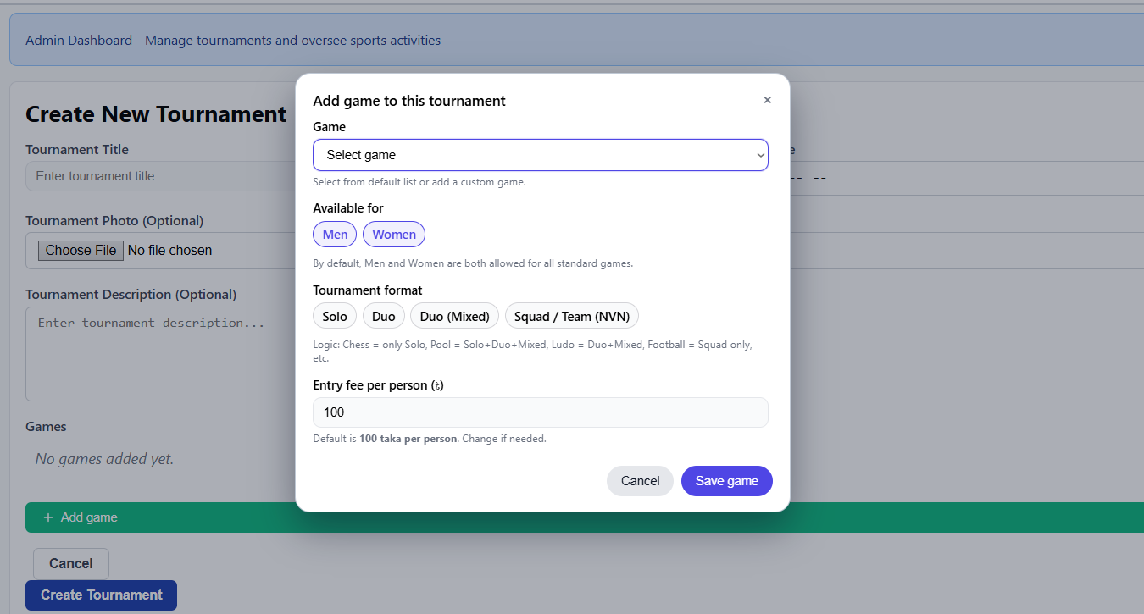

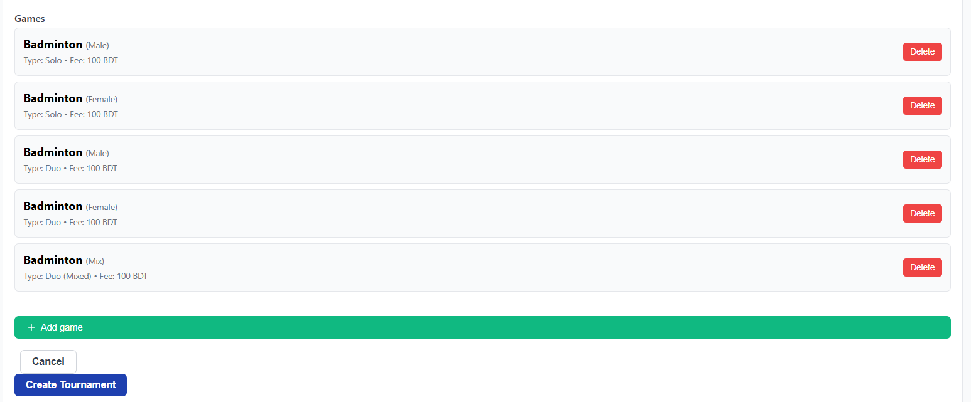

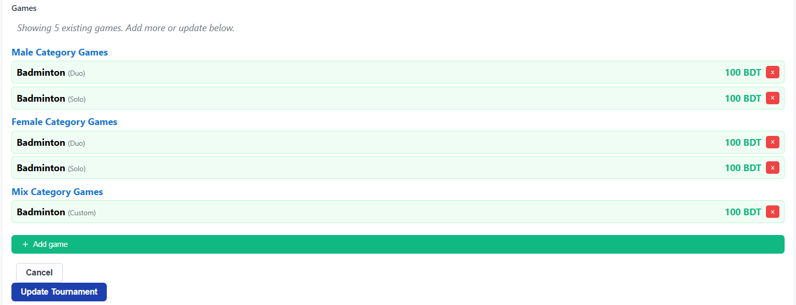

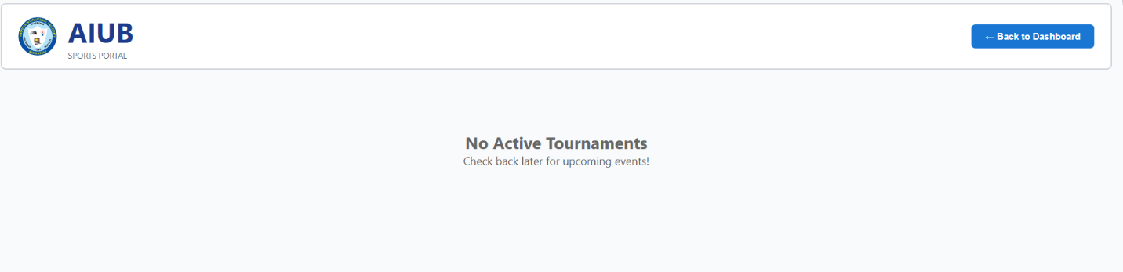

Scenario Description
In an AIUB Sports Management System, students can register for different games offered within tournaments. A game must have at least one student registered, although students are not required to join any game. Each game belongs to a tournament, and it cannot exist without one. Tournaments are created and managed by admins. Students and admins are stored separately in the system. Students log in using Microsoft Teams and maintain a profile containing details like name, gender, department, program level, phone number, and blood group. Some information, such as gender and department, becomes locked after the first submission, while the name can only be edited a limited number of times. Each tournament includes a title, description, registration deadline, and an image. An admin can create multiple tournaments, and every tournament can have multiple games such as football, cricket, or badminton, where each game is classified under male, female, or mixed categories. Students can register for any available game as long as the tournament registration deadline has not passed. They may join multiple games but cannot register more than once for the same game. Each registration records the registration date and payment status, which may be pending, paid, or failed. Unique IDs identify all students, admins, tournaments, games, and registrations. Foreign keys ensure proper relationships among these entities. To keep data consistent, triggers and sequences automatically generate IDs and timestamps. Overall, the system represents a real-world sports portal where students take part in tournaments and games, while admins handle tournament creation and game management.

ER Diagram

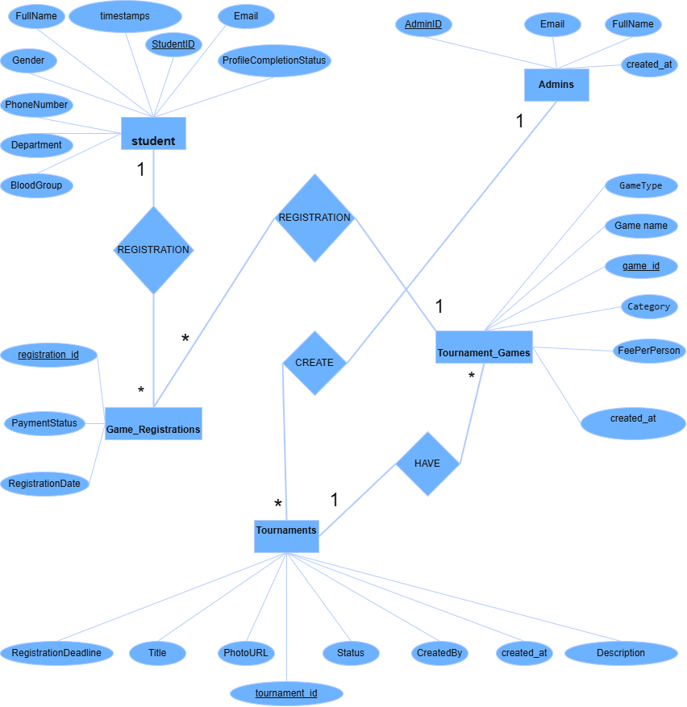

Normalization
RELATION–1 : USER REGISTRATION: (User ↔ Game)
UNF:
Student_registration( student_id , email, full_name, gender, program_level, department, blood_group, registration_id, registration_date, payment_status )
1NF:
There is no multivalued attribute. All attributes are atomic. Relation already in 1NF.
2NF:
1. student( student_id , email, full_name, gender, program_level, department, blood_group)
2. GAME_REGISTRATIONS( registration _id, registration_date, payment_status)
Partial Dependency:
student_id, email, full_name, gender, program_level, department, blood_group
(depend only on student_id ), registration_date, payment_status (depend on registration_id)
3NF:
No transitive dependency Relation already in 3NF.
Table Creation:
1. Student( student_id , email, full_name, gender, program_level, department, blood_group)
2. GAME_REGISTRATIONS( registration _id, registration_date, payment_status)

RELATION–2 : TOURNAMENT_CREATION
UNF:
tournament_creation( a_id, admin_name, admin_email,created_at tournament_id, title, photo_url, registration_deadline, status, description, created_at,CreatedBy )
1NF:
There is no multivalued attribute. Relation already in 1NF
2NF:
1. ADMINS ( a_id, admin_name, admin_email,created_at)
2. TOURNAMENTS( t_id, title, photo_url, registration_deadline, status, description, created_at,CreatedBy)
Partial Dependency:
admin_name, admin_email (depend on a_id) , registration_deadline, status (depend on t_id)
3NF:
No transitive dependency Relation already in 3NF.
Table Creation:
1. ADMINS(a_id, admin_name, admin_email,created_at)
2. TOURNAMENTS( t_id, title, photo_url,registration_deadline, status,description, created_at,CreatedBy)

RELATION–3 : TOURNAMENT_have_Tournament_Games:
UNF:
TOURNAMENTS_HAVE_GAMES( t_id, title, photo_url, registration_deadline, status, created_by, description, g_id, category, game_name, game_type, fee_per_person,created_at)
1NF:
There is no multivalued attribute.All attributes are atomic. Relation already in 1NF
2NF:
1. TOURNAMENTS(t_id (PK),title, photo_url, registration_deadline,status, created_by,
description)
2. TOURNAMENT_GAMES( g_id (PK),t_id (FK ) ,category, game_name, game_type,
fee_per_person)
Composite key: (t_id, g_id)
Partial dependencies:
title, photo_url, registration_deadline, status, created_by, description depends on t_id
category, game_name, game_type, fee_per_person depends on g_id
3NF:
No transitive dependency Relation already in 3NF.
Table Creation:
1. TOURNAMENTS (t_id, title, photo_url, registration_deadline, status, description, created_at,CreatedBy)
2. TOURNAMENT_GAMES(g_id ,category,game_name,game_type, fee_per_person, created_at)

RELATION–4 : Game_Registrations ↔ Tournament_Games
UNF:
GAME_REGISTRATION ( registration_id, registration_deadline, PaymentStatus g_id , category, game_name, game_type, fee_per_person, created_at)
1NF:
There is no multivalued attribute. All attributes are atomic. Relation already in 1NF.
2NF:
1. Game_Registrations ( registration_id, PaymentStatus, RegistrationDate)
2. TOURNAMENT_GAMES(g_id , category,game_name,game_type, fee_per_person)
Composite PK = (reg_id, g_id)
Partial dependencies: registration_deadline, PaymentStatus ( reg_id)
category, game_name, game_type, fee_per_person, created_at (g_id)
3NF:
No transitive dependency Relation already in 3NF.
Table Creation:
1. Game_Registrations ( registration_id, PaymentStatus, RegistrationDate)
2. TOURNAMENT_GAMES(g_id , category, game_name, game_type, fee_per_person)

Temporary Tables:
1.student_id, email, full_name, gender, program_level, department, blood_group
2.registration_id, registration_date, payment_status, student_id (FK)
3. a_id, admin_name, admin_email, created_at
4. t_id, title, photo_url, registration_deadline, status, description, created_at, CreatedBy, a_id(FK)
5. t_id, title, photo_url, registration_deadline, status, description, created_at, CreatedBy, a_id(FK)
6.g_id, category, game_name, game_type, fee_per_person, created_at, t_id(FK)
7.registration_id, registration_date, payment_status, student_id (FK), t_id(FK)
8. g_id, category, game_name, game_type, fee_per_person, created_at, t_id(FK)

Final Tables:
1. student_id, email, full_name, gender, program_level, department, blood_group
2. a_id, admin_name, admin_email, created_at
3. t_id, title, photo_url, registration_deadline, status, description, created_at, CreatedBy, a_id(FK)
4. registration_id, registration_date, payment_status, student_id (FK), t_id(FK)
5. g_id, category, game_name, game_type, fee_per_person, created_at, t_id(FK)

Schema Diagram
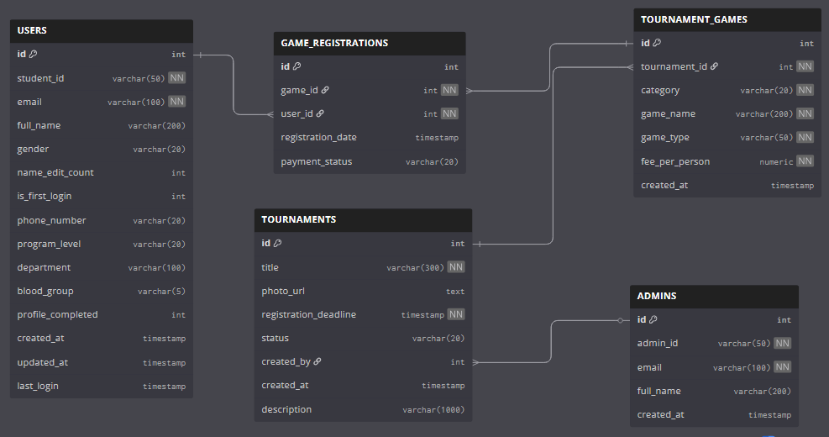
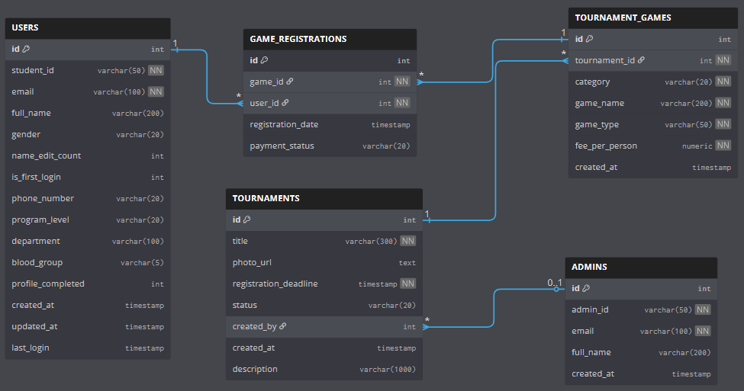

Table creation using SQL

Users Table

CREATE TABLE users (
id NUMBER PRIMARY KEY,
student_id VARCHAR2(50) NOT NULL UNIQUE,
email VARCHAR2(100) NOT NULL UNIQUE,
full_name VARCHAR2(200),
gender VARCHAR2(20),
name_edit_count NUMBER DEFAULT 0,
is_first_login NUMBER(1) DEFAULT 1,
created_at TIMESTAMP DEFAULT CURRENT_TIMESTAMP,
updated_at TIMESTAMP DEFAULT CURRENT_TIMESTAMP,
last_login TIMESTAMP,
phone_number VARCHAR2(20),
program_level VARCHAR2(20),
department VARCHAR2(100),
blood_group VARCHAR2(5),
profile_completed NUMBER(1) DEFAULT 0,
CONSTRAINT chk_gender CHECK (gender IN ('Male', 'Female', 'Other', NULL)),
CONSTRAINT chk_edit_count CHECK (name_edit_count >= 0 AND name_edit_count <= 3),
CONSTRAINT chk_first_login CHECK (is_first_login IN (0, 1)),
CONSTRAINT chk_program_level CHECK (program_level IN ('Undergraduate', 'Postgraduate', NULL)),
CONSTRAINT chk_blood_group CHECK (blood_group IN ('A+', 'A-', 'B+', 'B-', 'AB+', 'AB-', 'O+', 'O-', NULL))
);

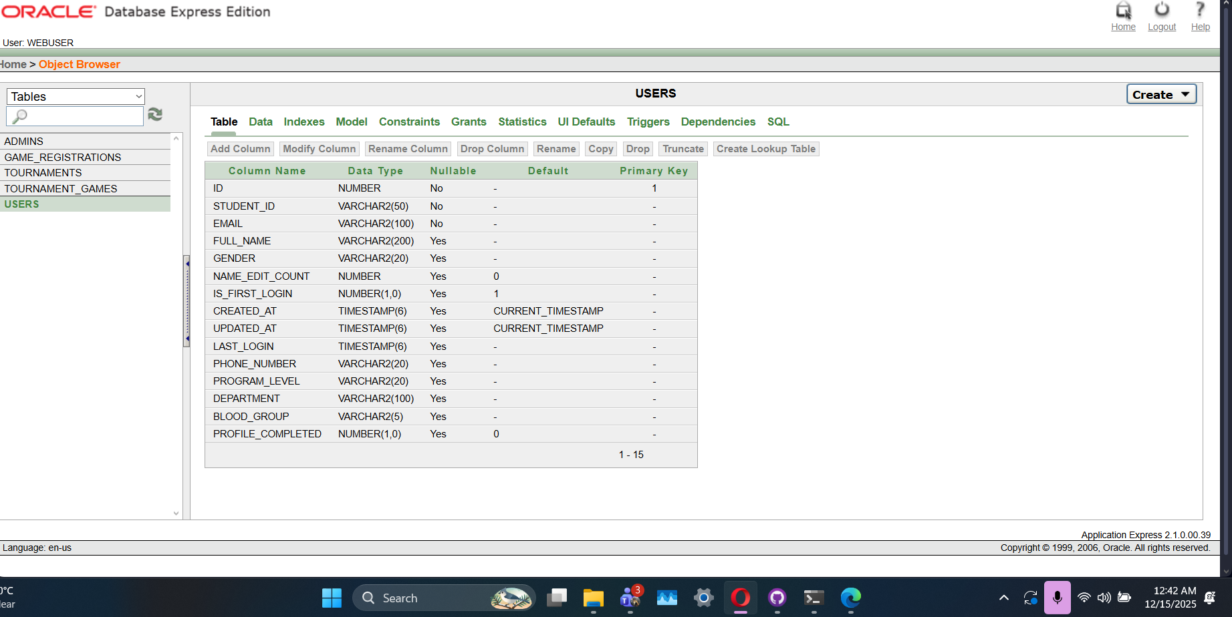

Admins Table
CREATE TABLE admins (
id NUMBER PRIMARY KEY,
admin_id VARCHAR2(50) NOT NULL UNIQUE,
email VARCHAR2(100) NOT NULL UNIQUE,
full_name VARCHAR2(200),
created_at TIMESTAMP DEFAULT CURRENT_TIMESTAMP
);
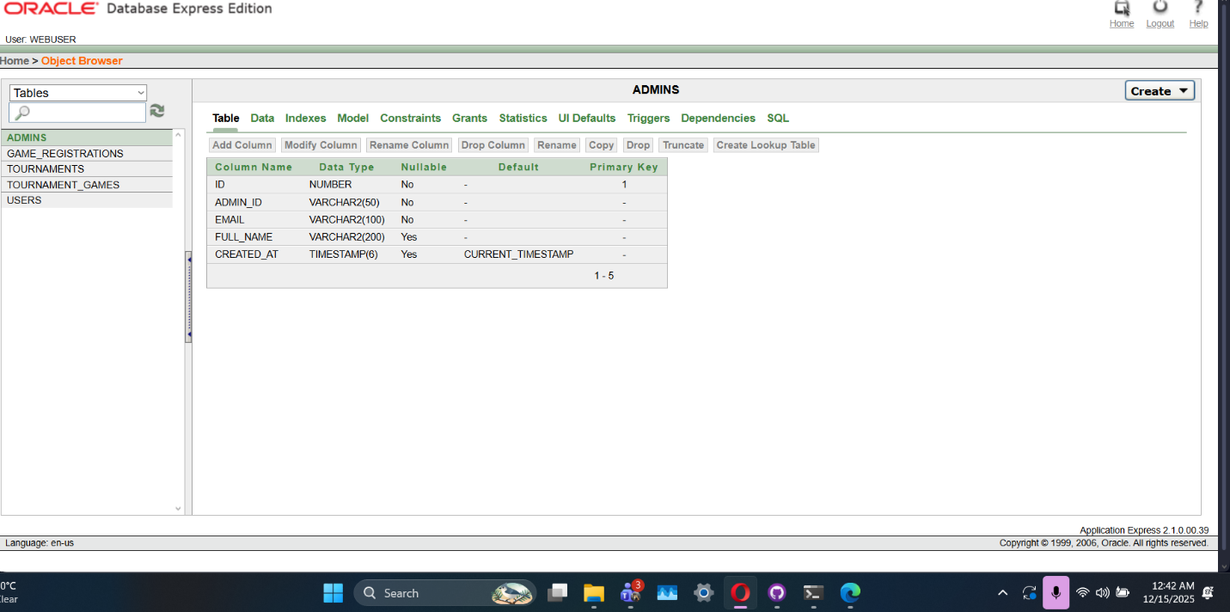
Tournaments Table
CREATE TABLE tournaments (
id NUMBER PRIMARY KEY,
title VARCHAR2(300) NOT NULL,
photo_url CLOB,
registration_deadline TIMESTAMP NOT NULL,
status VARCHAR2(20) DEFAULT 'ACTIVE',
created_by NUMBER REFERENCES admins(id),
created_at TIMESTAMP DEFAULT CURRENT_TIMESTAMP,
CONSTRAINT chk_tournament_status CHECK (status IN ('ACTIVE', 'CLOSED', 'COMPLETED'))
);

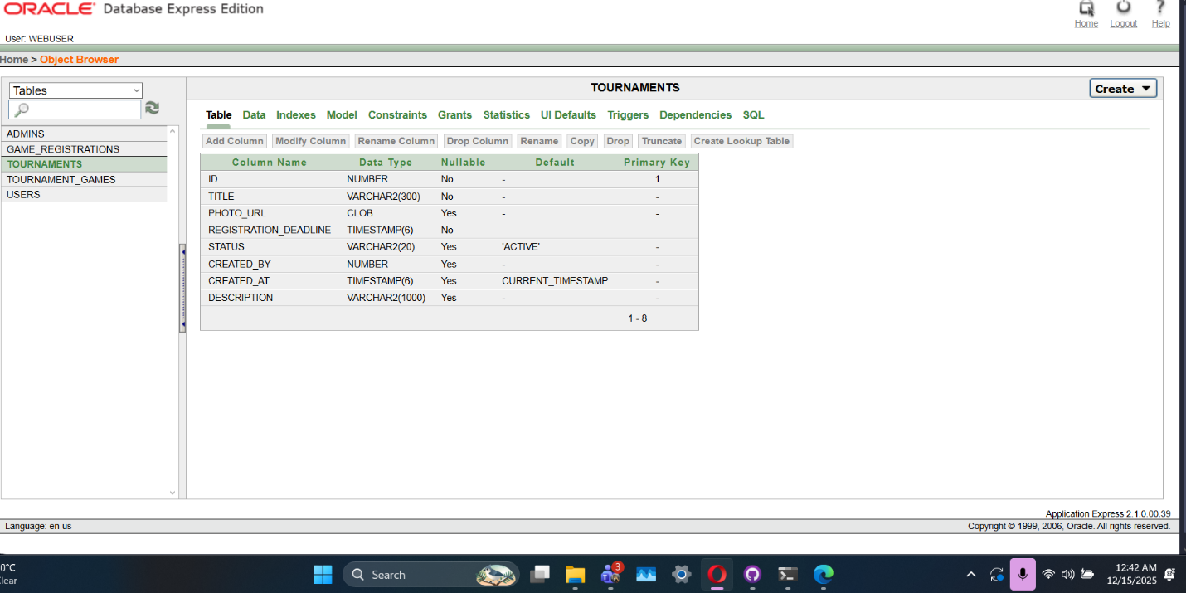

Tournament Games Table
CREATE TABLE tournament_games (
id NUMBER PRIMARY KEY,
tournament_id NUMBER NOT NULL REFERENCES tournaments(id) ON DELETE CASCADE,
category VARCHAR2(20) NOT NULL,
game_name VARCHAR2(200) NOT NULL,
game_type VARCHAR2(50) NOT NULL,
fee_per_person NUMBER NOT NULL,
created_at TIMESTAMP DEFAULT CURRENT_TIMESTAMP,
CONSTRAINT chk_game_category CHECK (category IN ('Male', 'Female', 'Mix')),
CONSTRAINT chk_game_type CHECK (game_type IN ('Solo', 'Duo', 'Custom'))
);

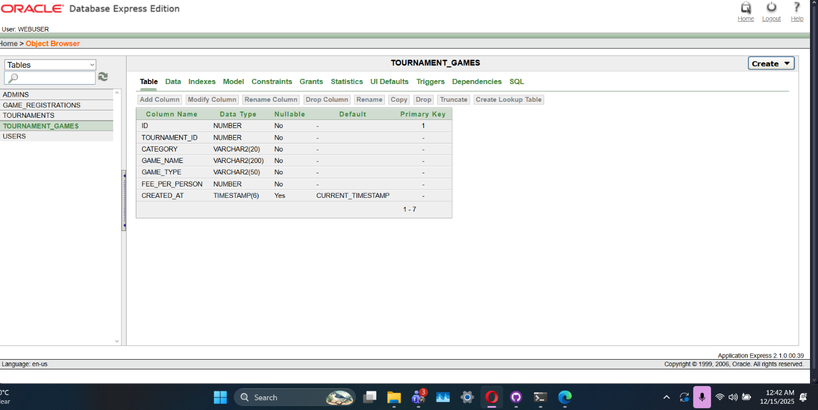

Game Registrations Table
CREATE TABLE game_registrations (
id NUMBER PRIMARY KEY,
game_id NUMBER NOT NULL REFERENCES tournament_games(id) ON DELETE CASCADE,
user_id NUMBER NOT NULL REFERENCES users(id),
registration_date TIMESTAMP DEFAULT CURRENT_TIMESTAMP,
payment_status VARCHAR2(20) DEFAULT 'PENDING',
CONSTRAINT chk_payment_status CHECK (payment_status IN ('PENDING', 'PAID', 'FAILED'))
);

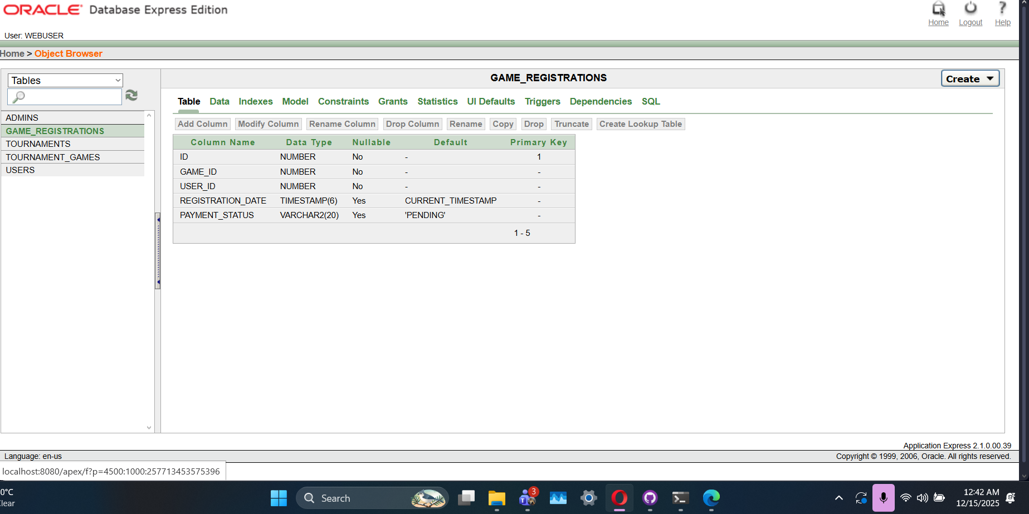

Data Insertion Using SQL
Insert Data into Users table
INSERT INTO users (id, student_id, email, full_name, gender, phone_number, program_level, department, blood_group, profile_completed, name_edit_count, is_first_login)
VALUES (user_id_seq.NEXTVAL, '24-56434-1', '24-56434-1@student.aiub.edu', 'John Smith', 'Male', '01712345678', 'Undergraduate', 'CSE', 'A+', 1, 0, 0);
INSERT INTO users (id, student_id, email, full_name, gender, phone_number, program_level, department, blood_group, profile_completed, name_edit_count, is_first_login)
VALUES (user_id_seq.NEXTVAL, '23-45123-2', '23-45123-2@student.aiub.edu', 'Sarah Johnson', 'Female', '01823456789', 'Undergraduate', 'EEE', 'B+', 1, 1, 0);
INSERT INTO users (id, student_id, email, full_name, gender, phone_number, program_level, department, blood_group, profile_completed, name_edit_count, is_first_login)
VALUES (user_id_seq.NEXTVAL, '22-34567-3', '22-34567-3@student.aiub.edu', 'Robert Davis', 'Male', '01634567890', 'Postgraduate', 'BBA', 'O+', 1, 2, 0);
INSERT INTO users (id, student_id, email, full_name, gender, phone_number, program_level, department, blood_group, profile_completed, name_edit_count, is_first_login)
VALUES (user_id_seq.NEXTVAL, '21-23456-4', '21-23456-4@student.aiub.edu', 'Emily Brown', 'Female', '01745678901', 'Undergraduate', 'English', 'AB-', 1, 0, 0);
INSERT INTO users (id, student_id, email, full_name, gender, phone_number, program_level, department, blood_group, profile_completed, name_edit_count, is_first_login)
VALUES (user_id_seq.NEXTVAL, '20-12345-5', '20-12345-5@student.aiub.edu', 'Michael Wilson', 'Male', '01556789012', 'Postgraduate', 'Law', 'B-', 1, 3, 0);
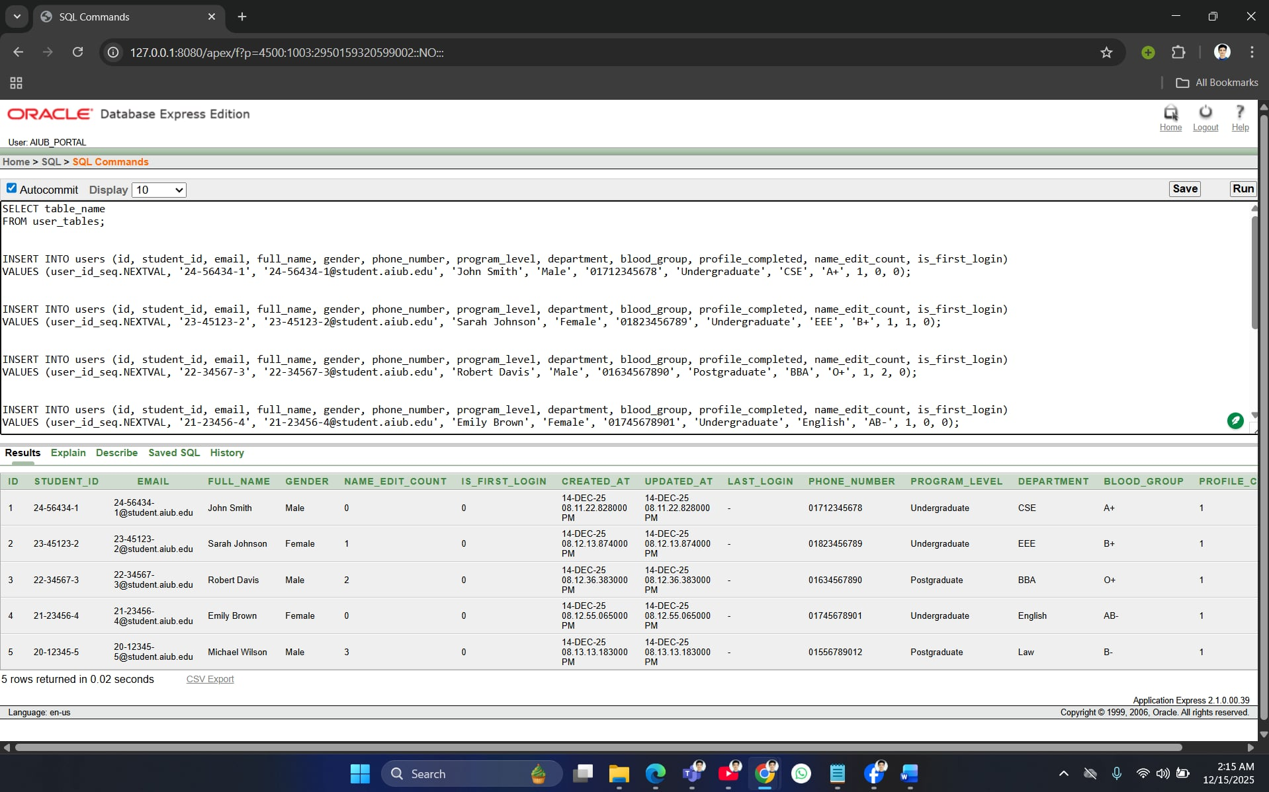

Insert Data into Admin table
INSERT INTO admins (id, admin_id, email, full_name)
VALUES (admin_id_seq.NEXTVAL, 'admin001', 'admin1@aiub.edu', 'Admin One');
INSERT INTO admins (id, admin_id, email, full_name)
VALUES (admin_id_seq.NEXTVAL, 'admin002', 'admin2@aiub.edu', 'Admin Two');
INSERT INTO admins (id, admin_id, email, full_name)
VALUES (admin_id_seq.NEXTVAL, 'admin003', 'admin3@aiub.edu', 'Admin Three');
INSERT INTO admins (id, admin_id, email, full_name)
VALUES (admin_id_seq.NEXTVAL, 'admin004', 'admin4@aiub.edu', 'Admin Four');
INSERT INTO admins (id, admin_id, email, full_name)
VALUES (admin_id_seq.NEXTVAL, 'admin005', 'admin5@aiub.edu', 'Admin Five');

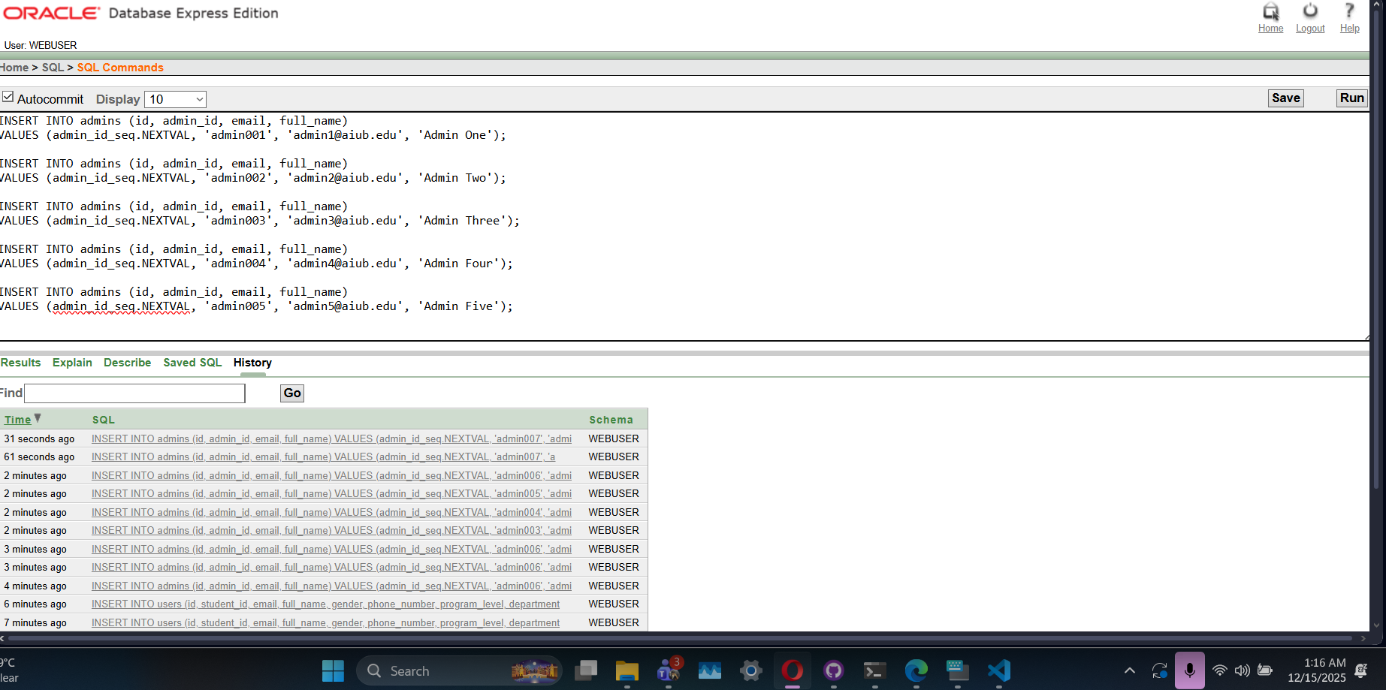

Insert Data into Tournaments table
INSERT INTO tournaments (id, title, photo_url, registration_deadline, status, created_by)
VALUES (tournament_id_seq.NEXTVAL, 'AIUB Annual Sports Festival 2025', 'https://example.com/images/sports_fest_2025.jpg', TO_DATE('2025-02-15 23:59:59', 'YYYY-MM-DD HH24:MI:SS'), 'ACTIVE', 1);
INSERT INTO tournaments (id, title, photo_url, registration_deadline, status, created_by)
VALUES (tournament_id_seq.NEXTVAL, 'Inter-Department Cricket Championship', 'https://example.com/images/cricket_champ.jpg', TO_DATE('2025-01-20 23:59:59', 'YYYY-MM-DD HH24:MI:SS'), 'ACTIVE', 2);
INSERT INTO tournaments (id, title, photo_url, registration_deadline, status, created_by)
VALUES (tournament_id_seq.NEXTVAL, 'AIUB Basketball Tournament', 'https://example.com/images/basketball_tour.jpg', TO_DATE('2025-02-10 23:59:59', 'YYYY-MM-DD HH24:MI:SS'), 'CLOSED', 1);
INSERT INTO tournaments (id, title, photo_url, registration_deadline, status, created_by)
VALUES (tournament_id_seq.NEXTVAL, 'AIUB Football League', 'https://example.com/images/football_league.jpg', TO_DATE('2025-01-25 23:59:59', 'YYYY-MM-DD HH24:MI:SS'), 'ACTIVE', 3);
INSERT INTO tournaments (id, title, photo_url, registration_deadline, status, created_by)
VALUES (tournament_id_seq.NEXTVAL, 'AIUB Chess Championship', 'https://example.com/images/chess_champ.jpg', TO_DATE('2025-02-05 23:59:59', 'YYYY-MM-DD HH24:MI:SS'), 'COMPLETED', 4);
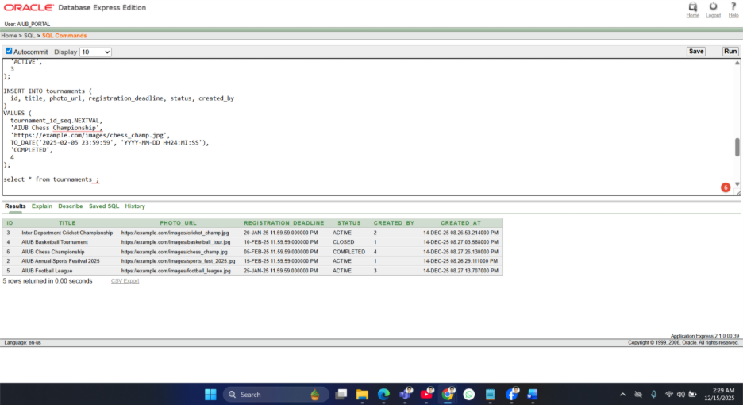
Insert Data into Tournament_games table
INSERT INTO tournament_games (id, tournament_id, category, game_name, game_type, fee_per_person)
VALUES (game_id_seq.NEXTVAL, 1, 'Male', 'Cricket', 'Custom', 500);
INSERT INTO tournament_games (id, tournament_id, category, game_name, game_type, fee_per_person)
VALUES (game_id_seq.NEXTVAL, 1, 'Female', 'Badminton', 'Solo', 300);
INSERT INTO tournament_games (id, tournament_id, category, game_name, game_type, fee_per_person)
VALUES (game_id_seq.NEXTVAL, 1, 'Mix', 'Volleyball', 'Custom', 400);
INSERT INTO tournament_games (id, tournament_id, category, game_name, game_type, fee_per_person)
VALUES (game_id_seq.NEXTVAL, 2, 'Male', 'Cricket', 'Custom', 600);
INSERT INTO tournament_games (id, tournament_id, category, game_name, game_type, fee_per_person)
VALUES (game_id_seq.NEXTVAL, 3, 'Mix', 'Basketball', 'Custom', 450);
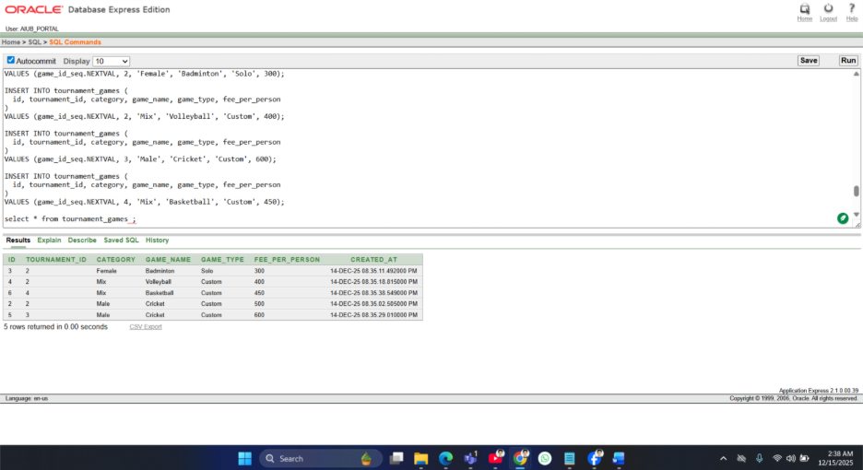

Insert Data into Game_registrations table
INSERT INTO game_registrations (id, game_id, user_id, payment_status)
VALUES (registration_id_seq.NEXTVAL, 1, 1, 'PAID');
INSERT INTO game_registrations (id, game_id, user_id, payment_status)
VALUES (registration_id_seq.NEXTVAL, 2, 2, 'PENDING');
INSERT INTO game_registrations (id, game_id, user_id, payment_status)
VALUES (registration_id_seq.NEXTVAL, 3, 3, 'PAID');
INSERT INTO game_registrations (id, game_id, user_id, payment_status)
VALUES (registration_id_seq.NEXTVAL, 4, 4, 'FAILED');
INSERT INTO game_registrations (id, game_id, user_id, payment_status)
VALUES (registration_id_seq.NEXTVAL, 5, 5, 'PAID');
COMMIT;
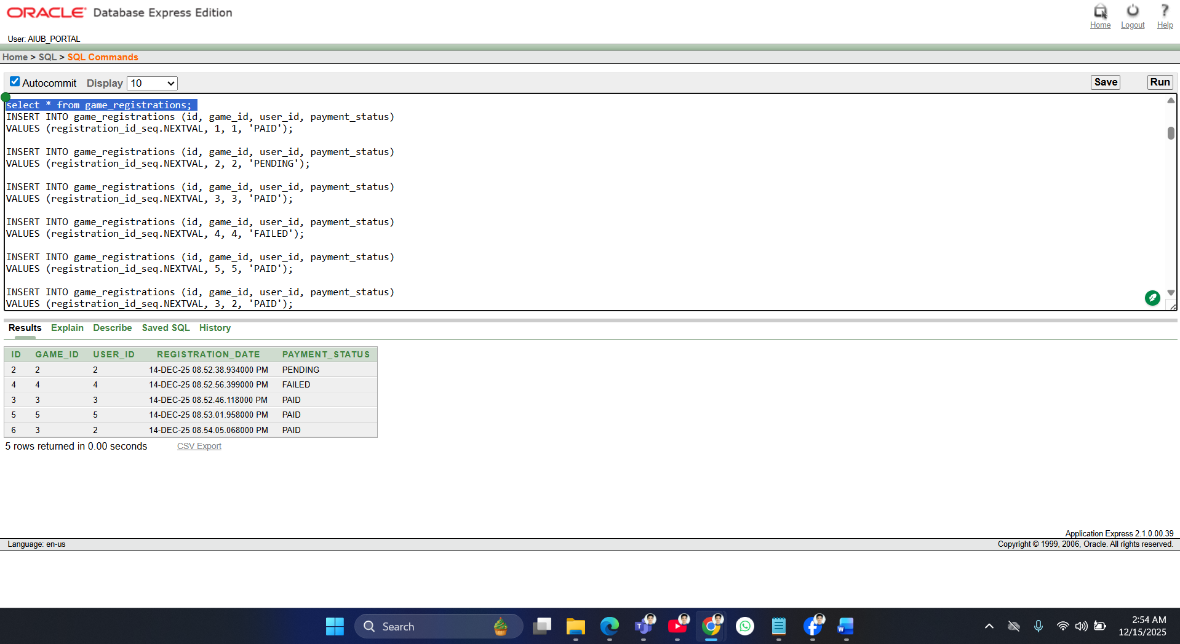

Basic PL/SQL
2 Variables
1. DECLARE
v_total_users NUMBER;
BEGIN
SELECT COUNT(*) INTO v_total_users FROM users;
DBMS_OUTPUT.PUT_LINE('Total Users: ' || v_total_users);
END;
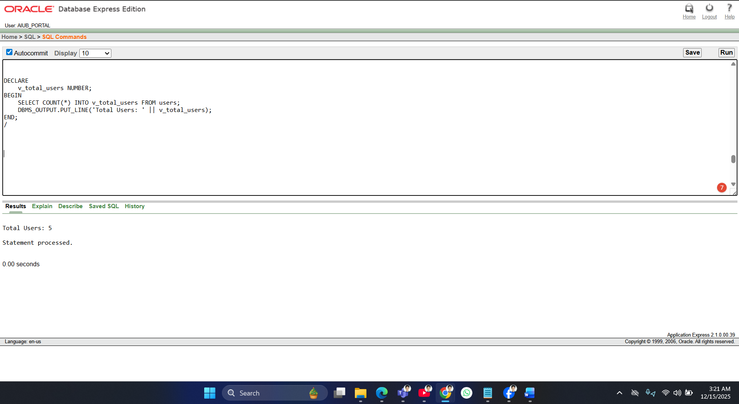

2. DECLARE
v_first_user_name VARCHAR2(100);
BEGIN
SELECT full_name INTO v_first_user_name FROM users WHERE id = 1;
DBMS_OUTPUT.PUT_LINE('First User Name: ' || v_first_user_name);
END;
/

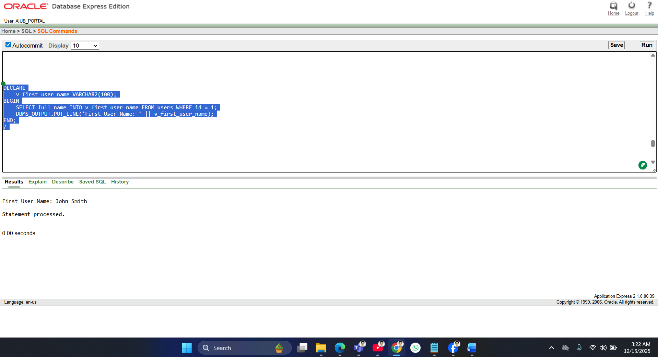
2 Operators
1.DECLARE
v_sum NUMBER;
BEGIN
v_sum := 5 + 10;
DBMS_OUTPUT.PUT_LINE('5 + 10 = ' || v_sum);
END;
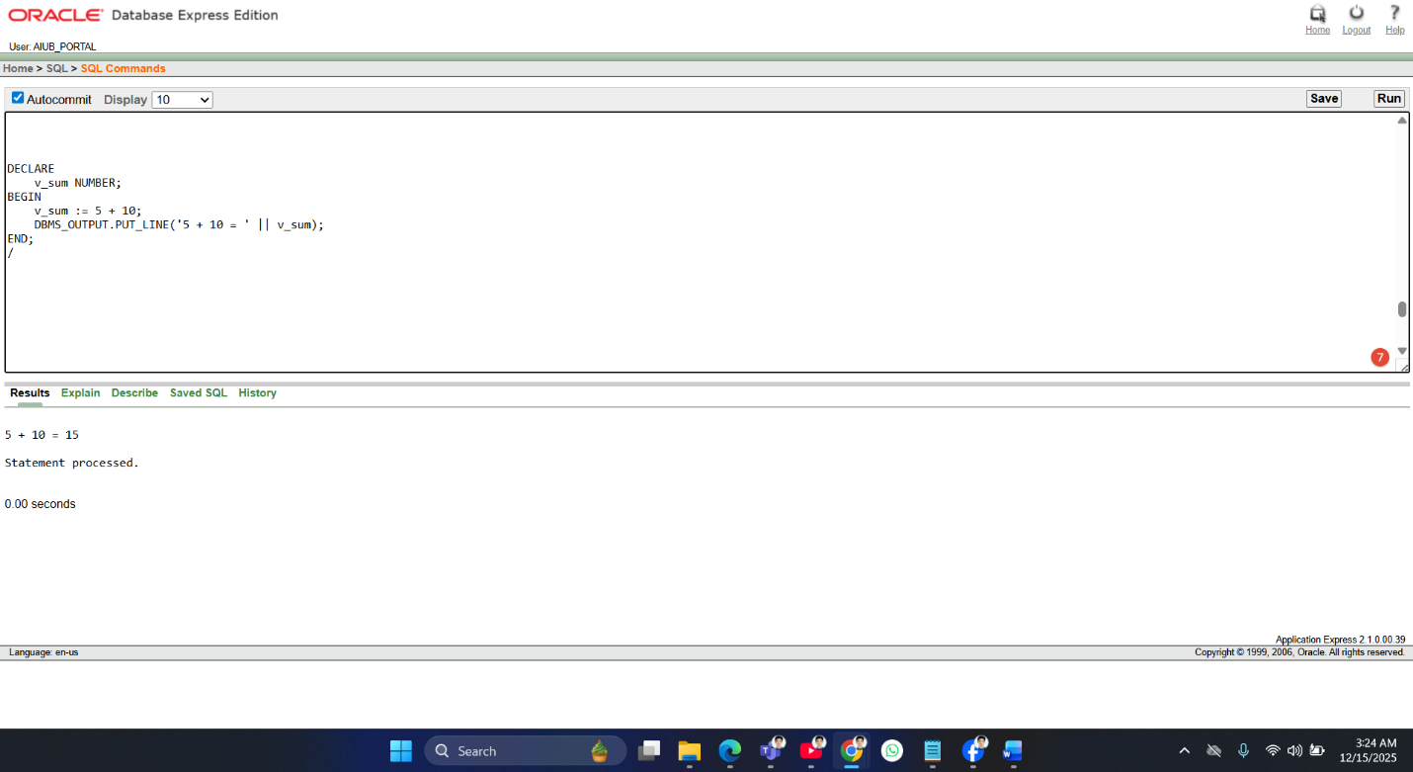

2.DECLARE
v_count NUMBER;
BEGIN
SELECT COUNT(*) INTO v_count FROM users;
IF v_count > 3 THEN
DBMS_OUTPUT.PUT_LINE('More than 3 users.');
ELSE
DBMS_OUTPUT.PUT_LINE('3 or fewer users.');
END IF;
END;
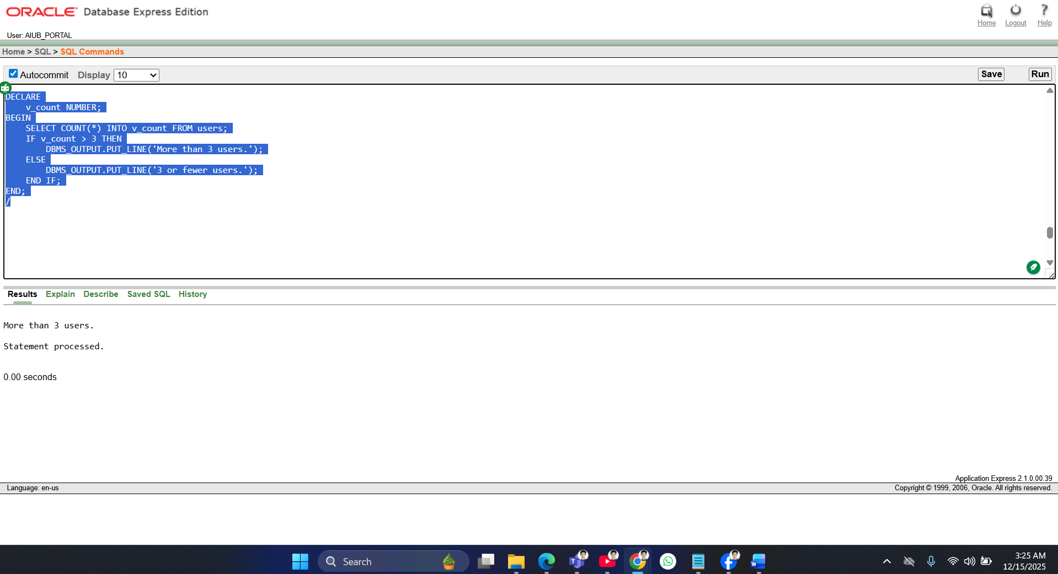

2 Single-row function
1. DECLARE
v_upper_name VARCHAR2(100);
BEGIN
SELECT UPPER(full_name) INTO v_upper_name FROM users WHERE id = 1;
DBMS_OUTPUT.PUT_LINE('Upper case name: ' || v_upper_name);
END;
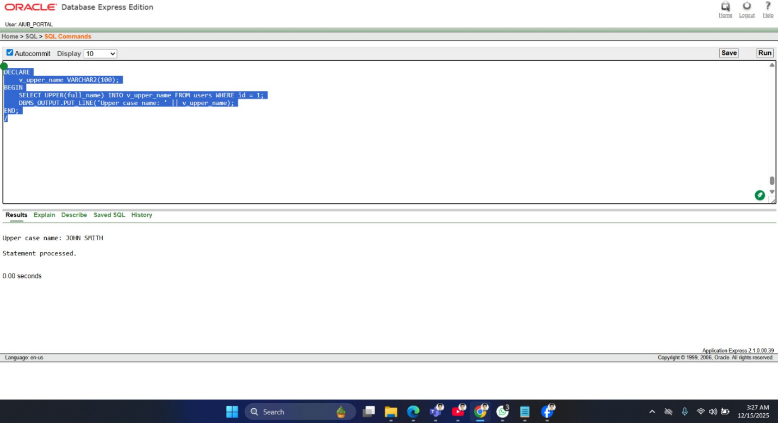
2. DECLARE
v_name_length NUMBER;
BEGIN
SELECT LENGTH(full_name) INTO v_name_length FROM users WHERE id = 1;
DBMS_OUTPUT.PUT_LINE('Name length: ' || v_name_length);
END;

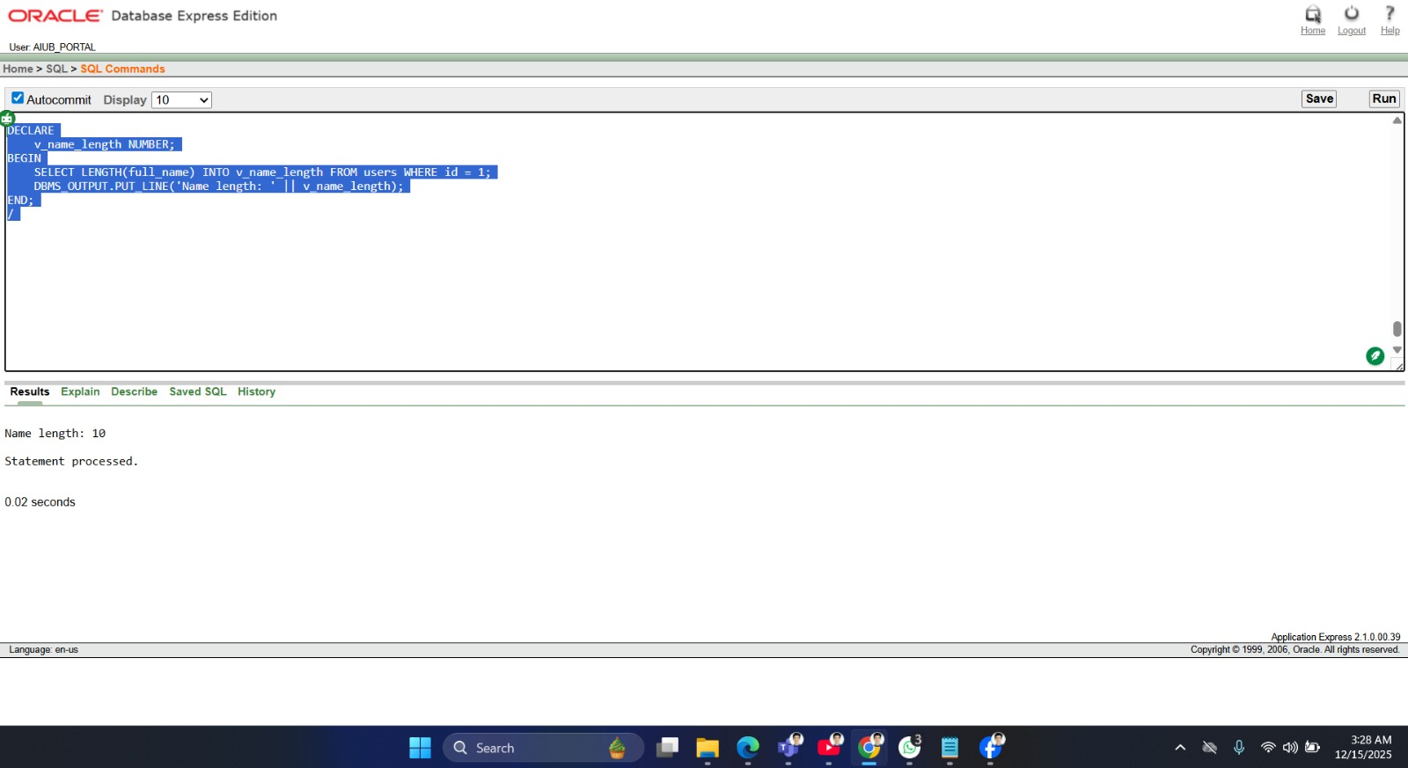
Z

2 group function
1. DECLARE
v_count NUMBER;
BEGIN
SELECT COUNT(*) INTO v_count FROM users;
DBMS_OUTPUT.PUT_LINE('Total Users: ' || v_count);
END;
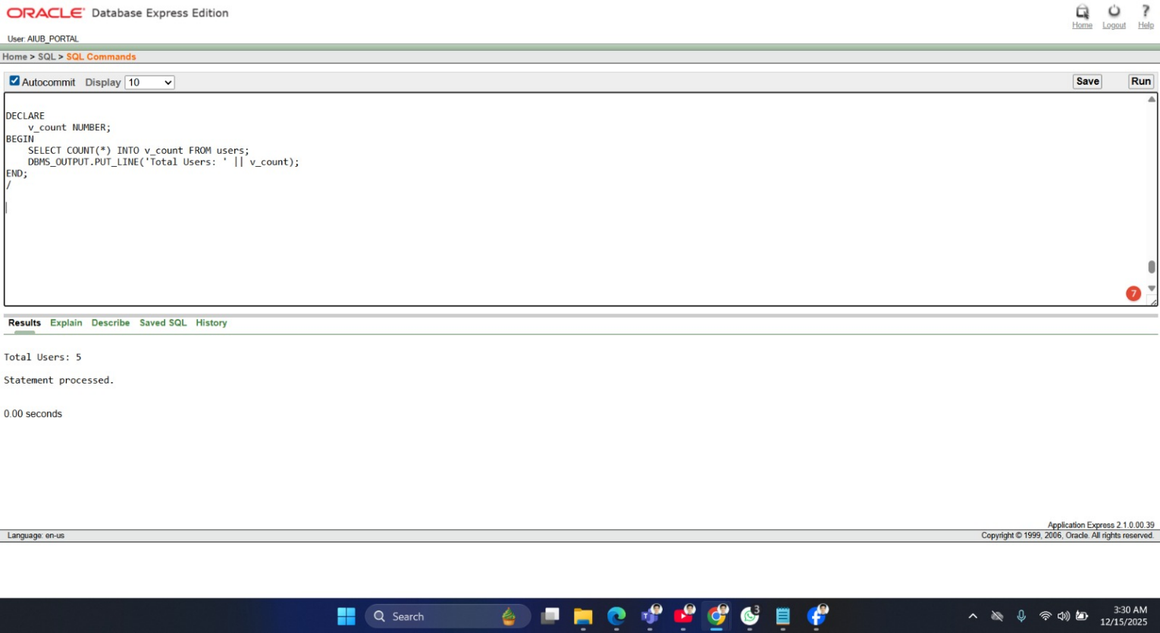

2 loop
2. DECLARE
v_avg_length NUMBER;
BEGIN
SELECT AVG(LENGTH(full_name)) INTO v_avg_length FROM users;
DBMS_OUTPUT.PUT_LINE('Average Name Length: ' || ROUND(v_avg_length,2));
END;
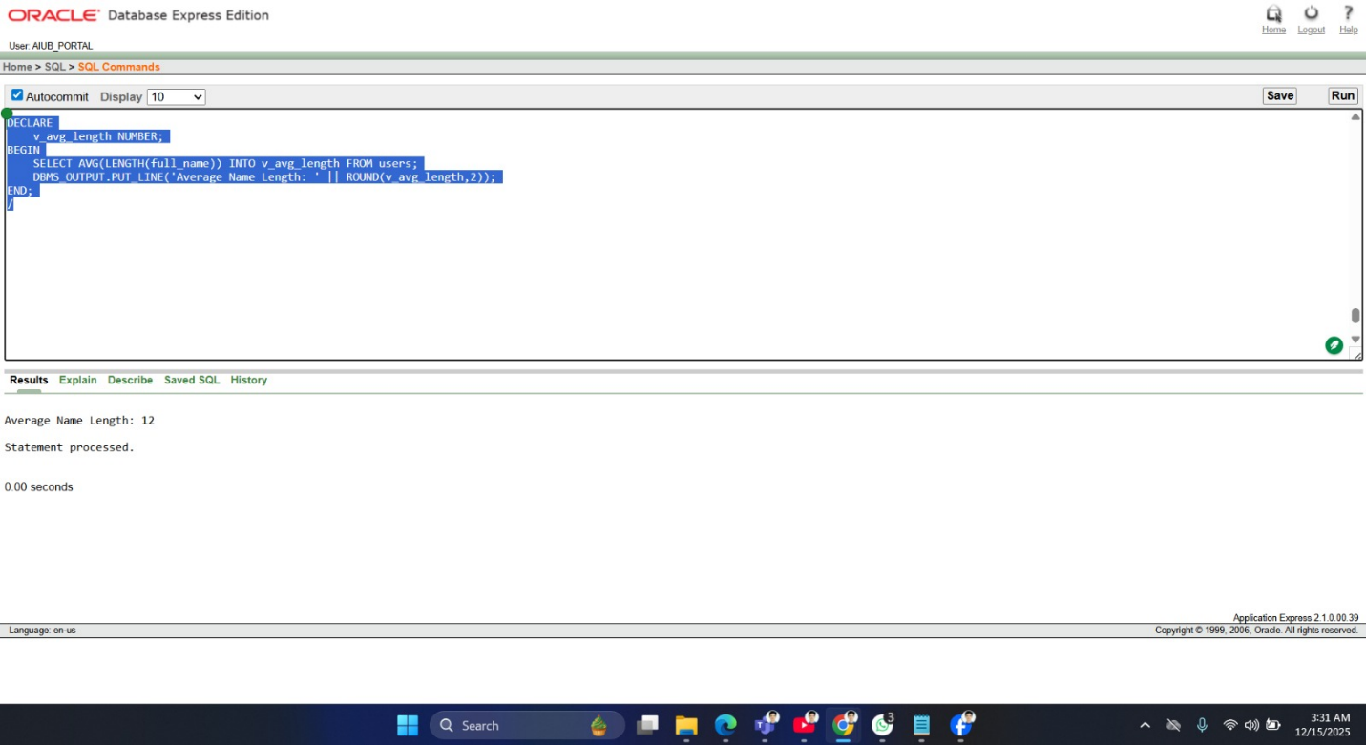

2 conditional statements
1. DECLARE
v_count NUMBER;
BEGIN
SELECT COUNT(*) INTO v_count FROM users;
IF v_count > 3 THEN
DBMS_OUTPUT.PUT_LINE('More than 3 users.');
ELSE
DBMS_OUTPUT.PUT_LINE('3 or fewer users.');
END IF; END;
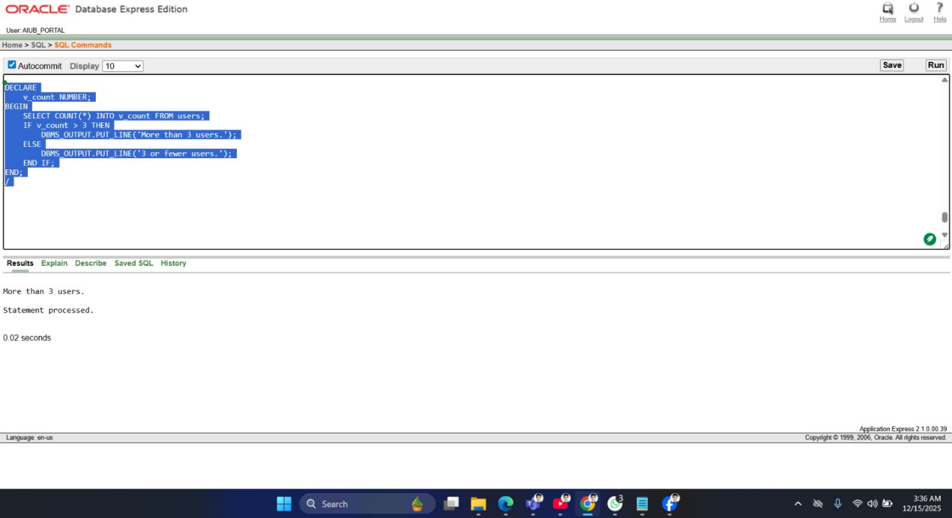

2.BEGIN
FOR rec IN (SELECT full_name, program_level FROM users) LOOP
CASE rec.program_level
WHEN 'Undergraduate' THEN DBMS_OUTPUT.PUT_LINE(rec.full_name || ' is Undergraduate');
WHEN 'Postgraduate' THEN DBMS_OUTPUT.PUT_LINE(rec.full_name || ' is Postgraduate');
END CASE;
END LOOP;
END;
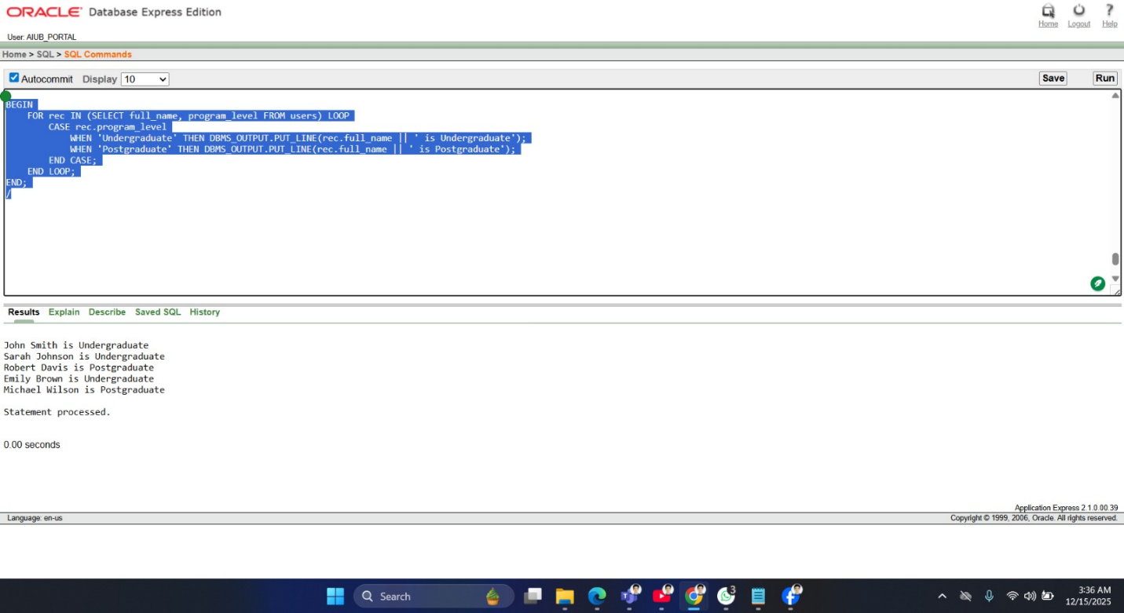

2 Subquery
DECLARE
v_dept_count NUMBER;
BEGIN
SELECT COUNT(*) INTO v_dept_count
FROM users
WHERE department = (SELECT department FROM users WHERE id = 1);
DBMS_OUTPUT.PUT_LINE('Users in same department as user 1: ' || v_dept_count);
END;
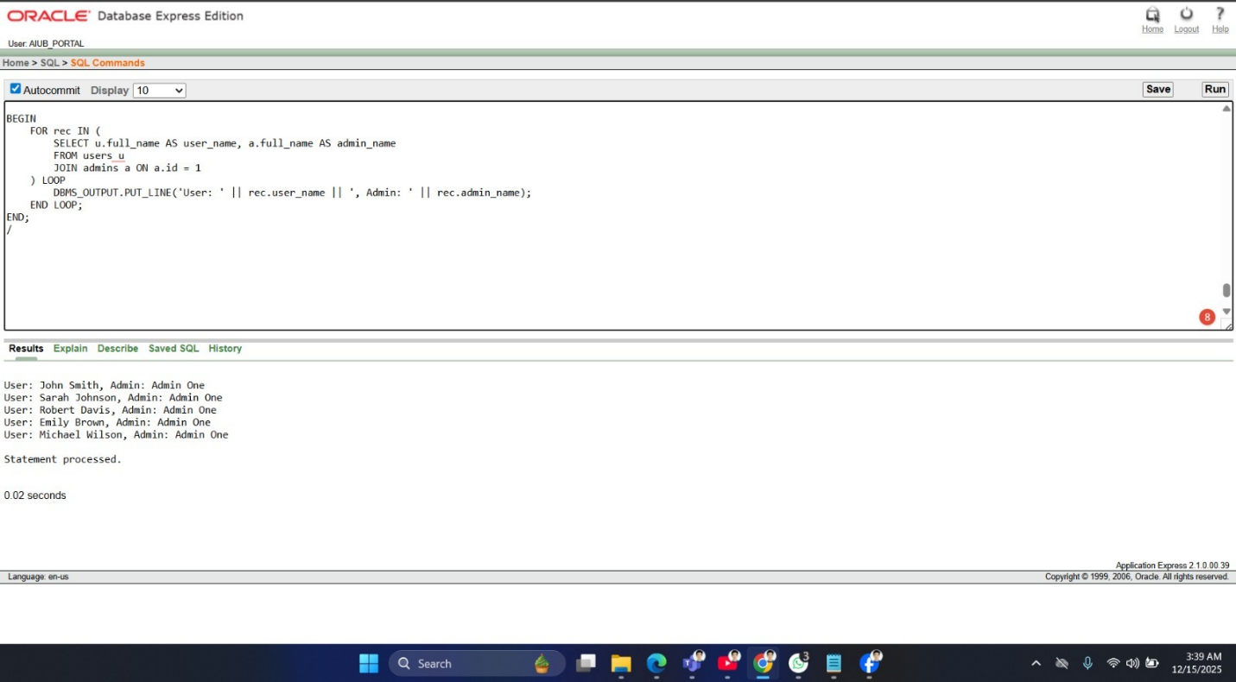

2.DECLARE
v_email VARCHAR2(100);
BEGIN
SELECT email INTO v_email
FROM users
WHERE id = (SELECT MAX(id) FROM users);
DBMS_OUTPUT.PUT_LINE('Email of user with max ID: ' || v_email);
END;
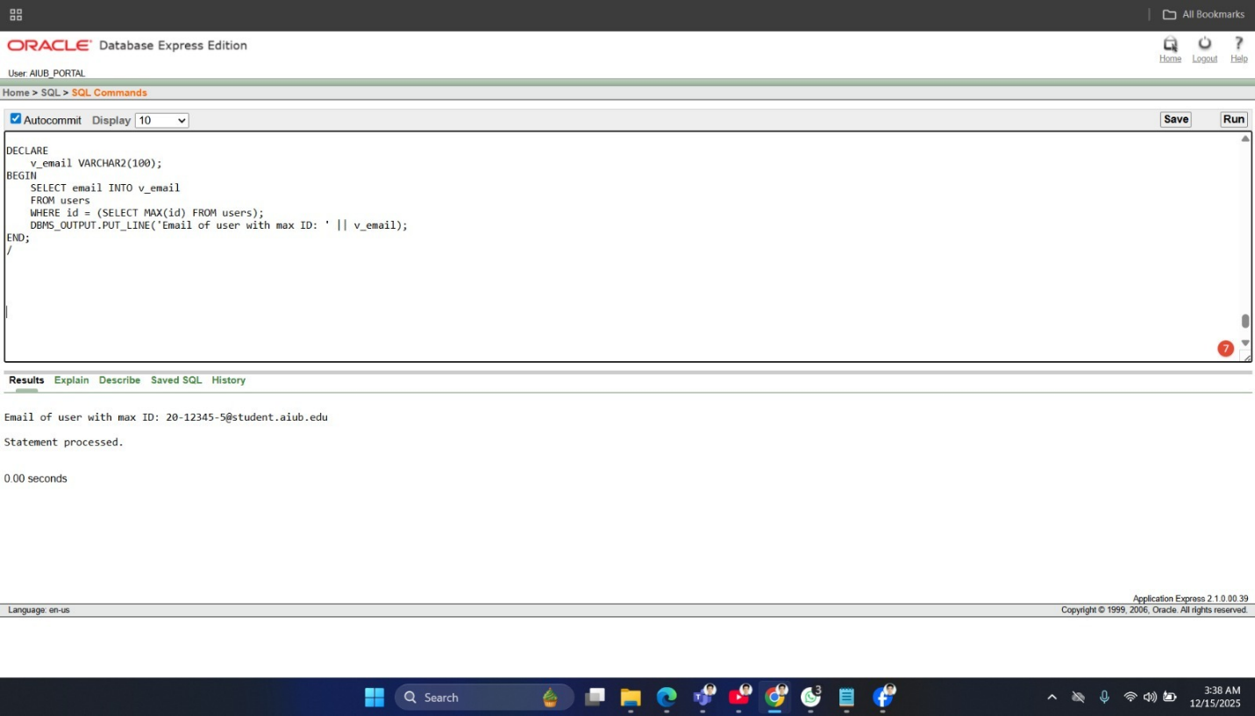

2 Joining
1. BEGIN
FOR rec IN (
SELECT u.full_name AS user_name, a.full_name AS admin_name
FROM users u
JOIN admins a ON a.id = 1 ) LOOP
DBMS_OUTPUT.PUT_LINE('User: ' || rec.user_name || ', Admin: ' || rec.admin_name);
END LOOP;
END;
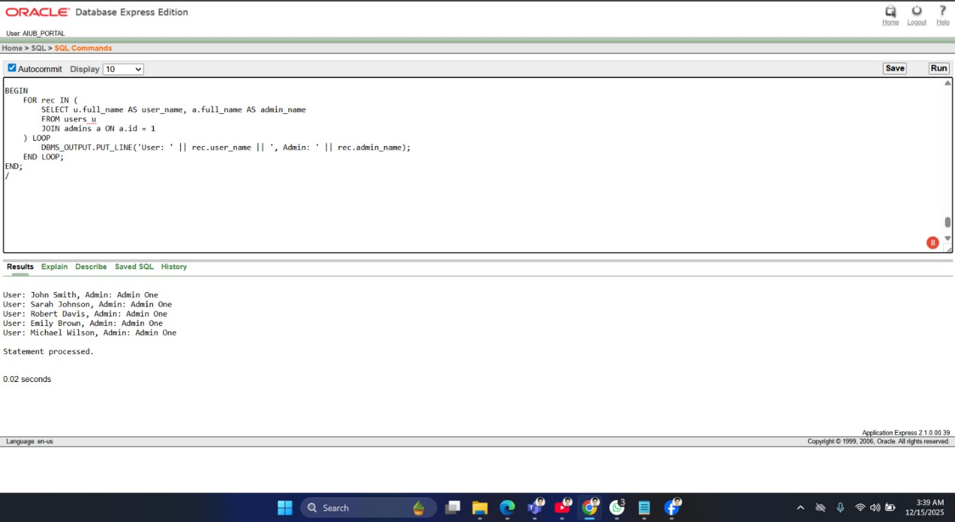

2. BEGIN
FOR rec IN (
SELECT u.full_name AS user_name, a.full_name AS admin_name
FROM users u, admins a
WHERE a.id = 2 AND u.id <= 3
) LOOP
DBMS_OUTPUT.PUT_LINE('User: ' || rec.user_name || ', Admin: ' || rec.admin_name);
END LOOP;
END;
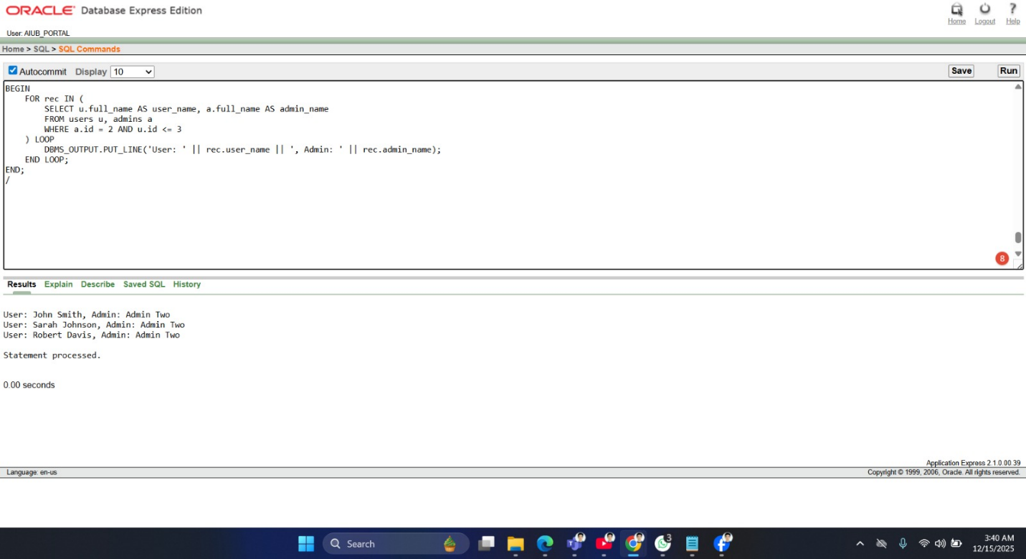

Advance
2 Stored Functions

Advance PL/SQL
2 Stored functions
Function 1: Get total users
CREATE OR REPLACE FUNCTION get_total_users RETURN NUMBER IS
v_count NUMBER;
BEGIN
SELECT COUNT(*) INTO v_count FROM users;
RETURN v_count;
END;
/
Test Function 1
BEGIN
DBMS_OUTPUT.PUT_LINE('Total Users: ' || get_total_users);
END;
/
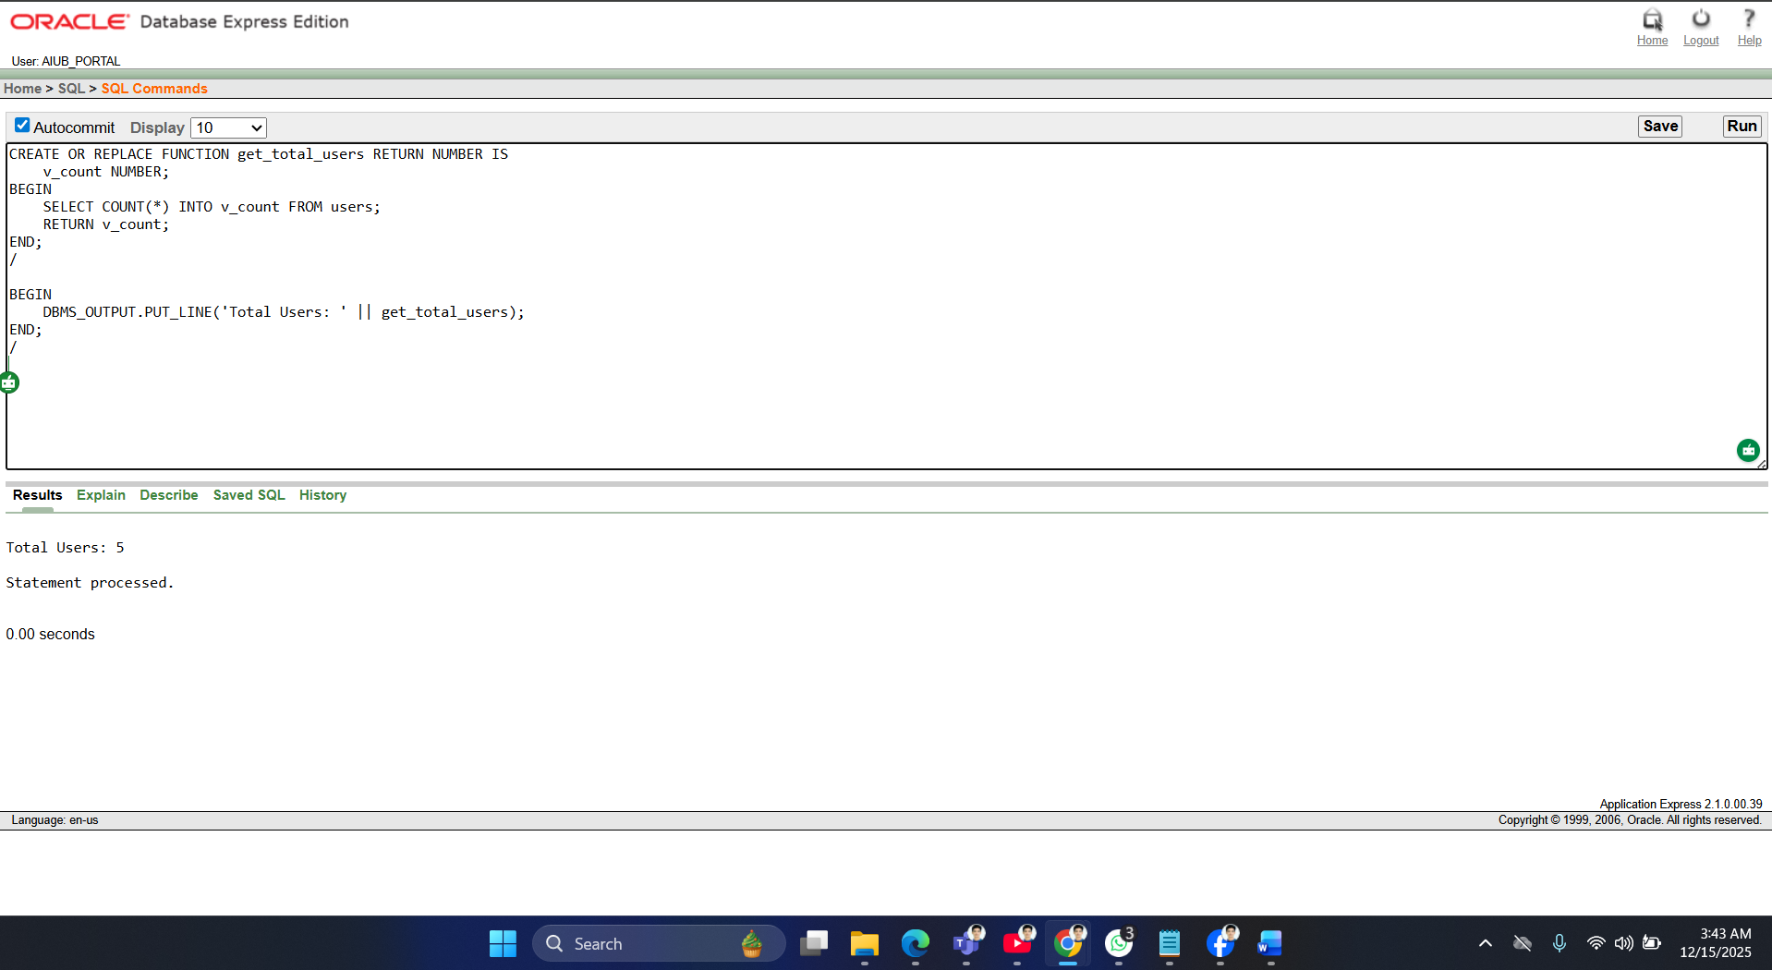

Function 2: Get email by student_id
CREATE OR REPLACE FUNCTION get_email(p_student_id VARCHAR2) RETURN VARCHAR2 IS
v_email VARCHAR2(100);
BEGIN
SELECT email INTO v_email FROM users WHERE student_id = p_student_id;
RETURN v_email;
END;
/
Test Function 2
BEGIN
DBMS_OUTPUT.PUT_LINE('Email: ' || get_email('24-56434-1'));
END;
/
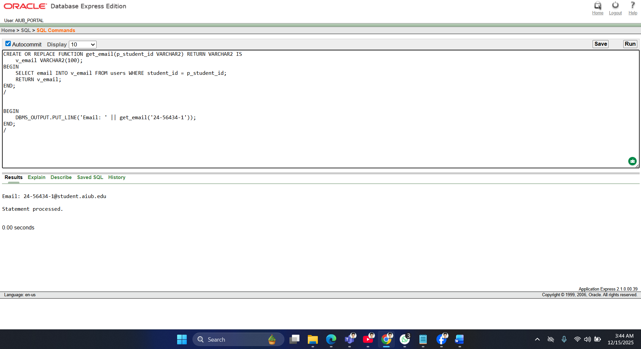
2. Stored Procedures
Procedure 1: Print all usernames
CREATE OR REPLACE PROCEDURE print_all_users IS
BEGIN
FOR rec IN (SELECT full_name FROM users) LOOP
DBMS_OUTPUT.PUT_LINE('User: ' || rec.full_name);
END LOOP;
END;
/
-- Test Procedure 1
BEGIN
print_all_users;
END;
/
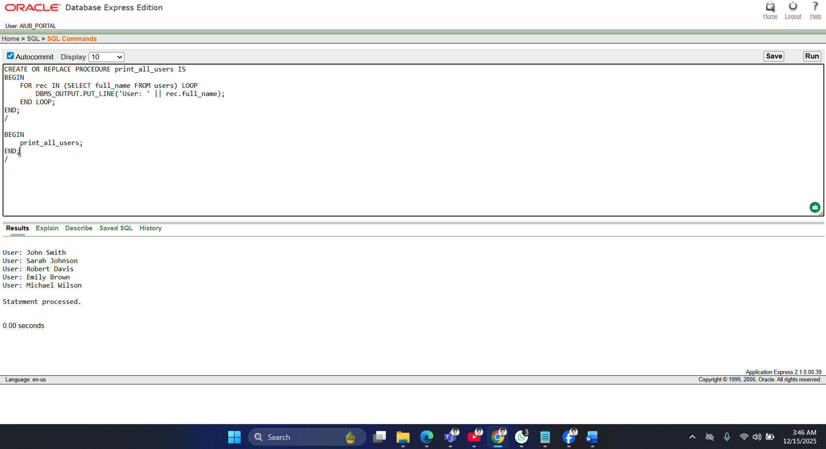
Procedure 2: Update name_edit_count for a student
CREATE OR REPLACE PROCEDURE update_name_edit(p_id NUMBER) IS
BEGIN
UPDATE users SET name_edit_count = name_edit_count + 1 WHERE id = p_id;
COMMIT;
END;
Test Procedure 2
BEGIN
update_name_edit(1); END;
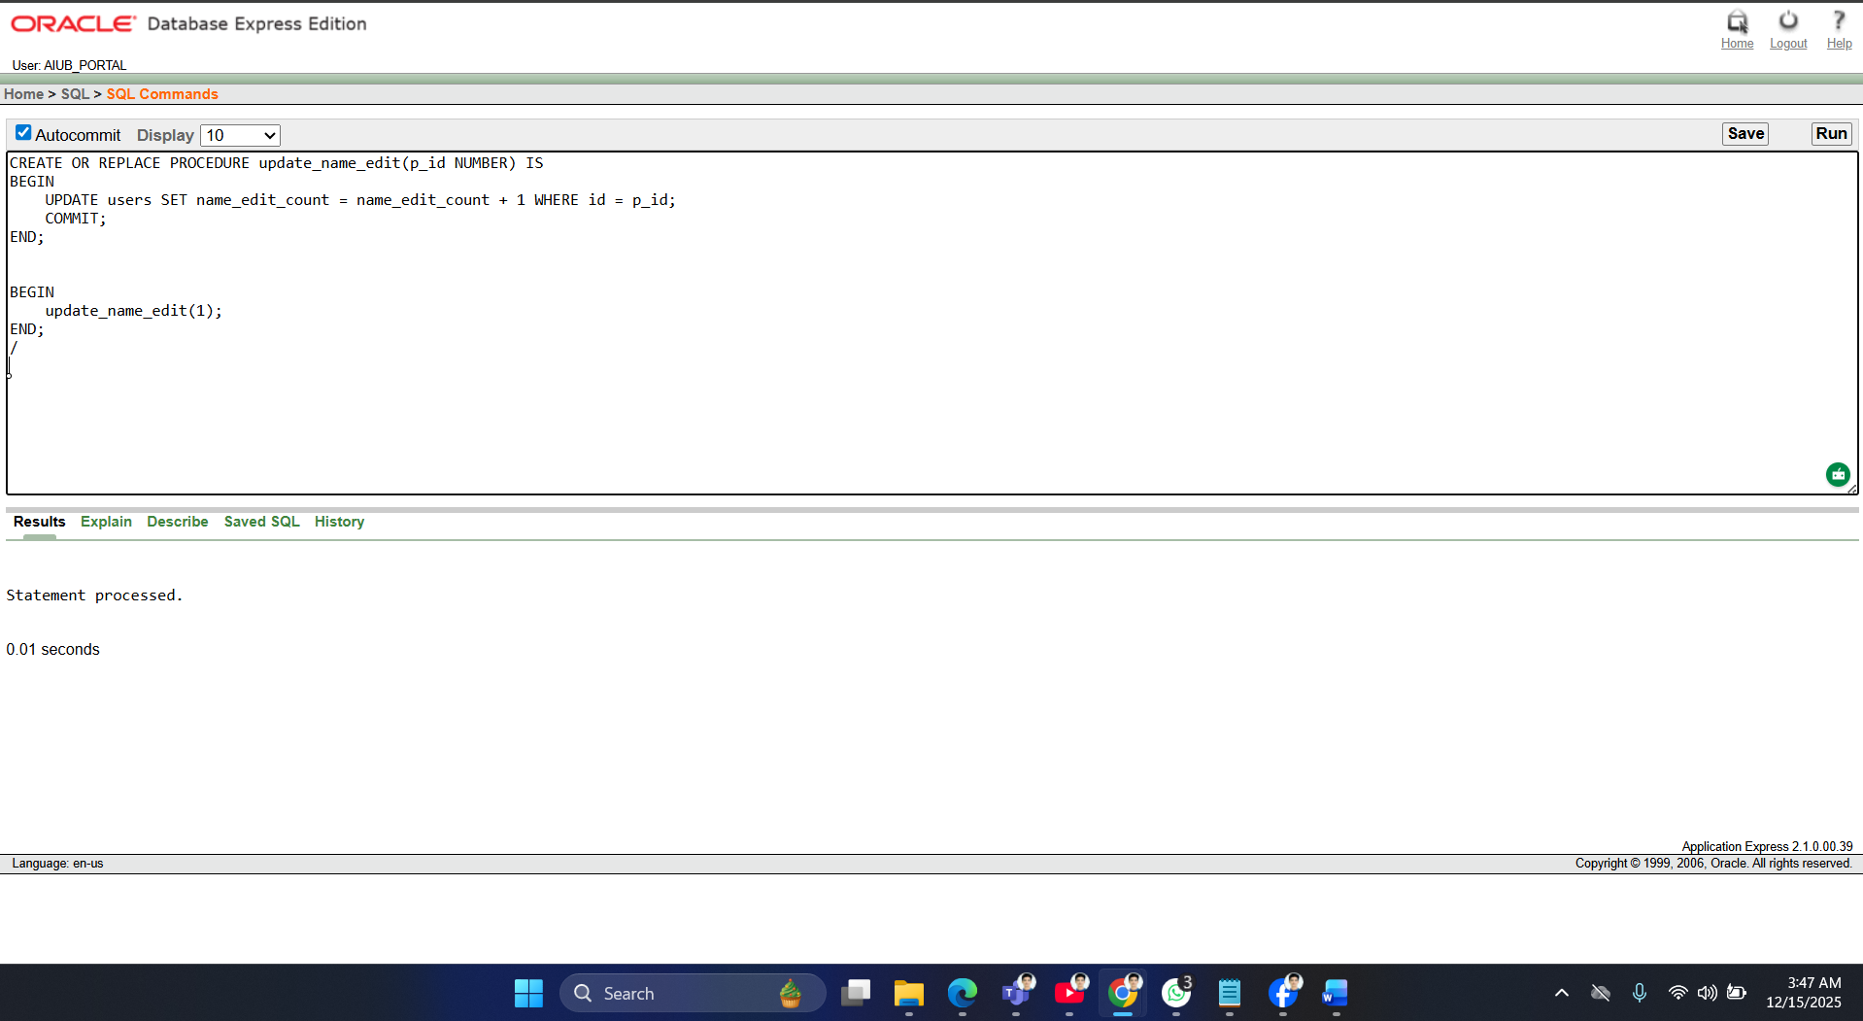
2 Table-Based Record
Example 1: Using %ROWTYPE
DECLARE
v_user users%ROWTYPE;
BEGIN
SELECT * INTO v_user FROM users WHERE id = 1;
DBMS_OUTPUT.PUT_LINE('Name: ' || v_user.full_name || ', Email: ' || v_user.email);
END;
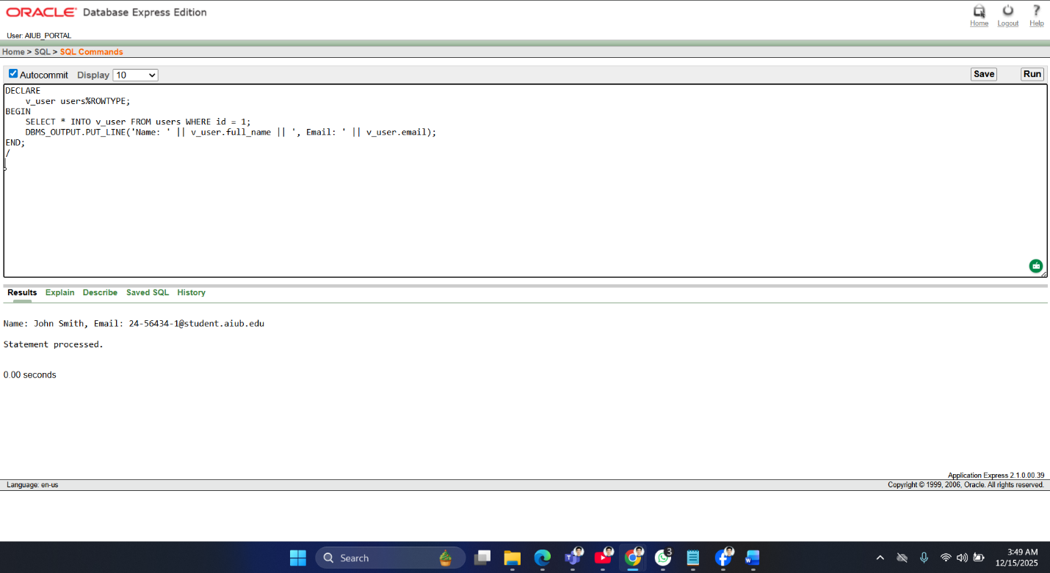

Example 2: Table of records
DECLARE
TYPE t_users IS TABLE OF users%ROWTYPE;
v_users t_users;
BEGIN
SELECT * BULK COLLECT INTO v_users FROM users WHERE id <= 3;
FOR i IN 1..v_users.COUNT LOOP
DBMS_OUTPUT.PUT_LINE('User: ' || v_users(i).full_name);
END LOOP;
END;
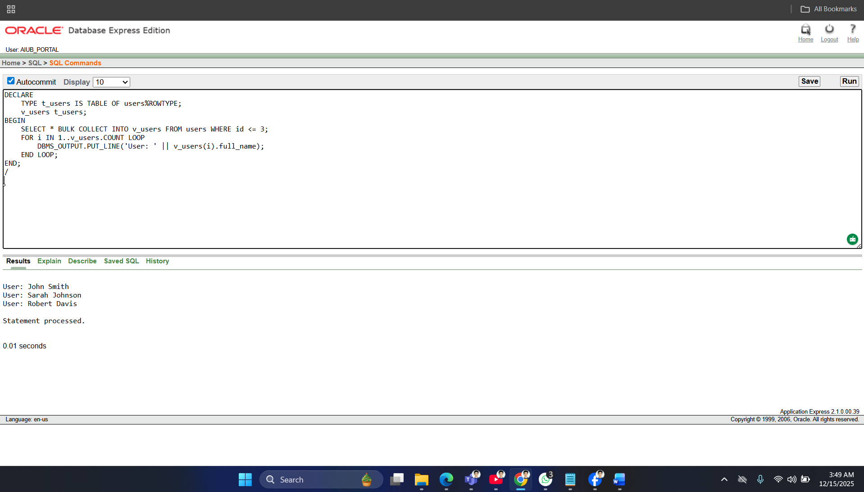

2 Explicit Cursor
Cursor 1: Print all emails
DECLARE
CURSOR c_users IS SELECT email FROM users;
v_email users.email%TYPE;
BEGIN
OPEN c_users;
LOOP
FETCH c_users INTO v_email;
EXIT WHEN c_users%NOTFOUND;
DBMS_OUTPUT.PUT_LINE('Email: ' || v_email);
END LOOP;
CLOSE c_users;
END;
/
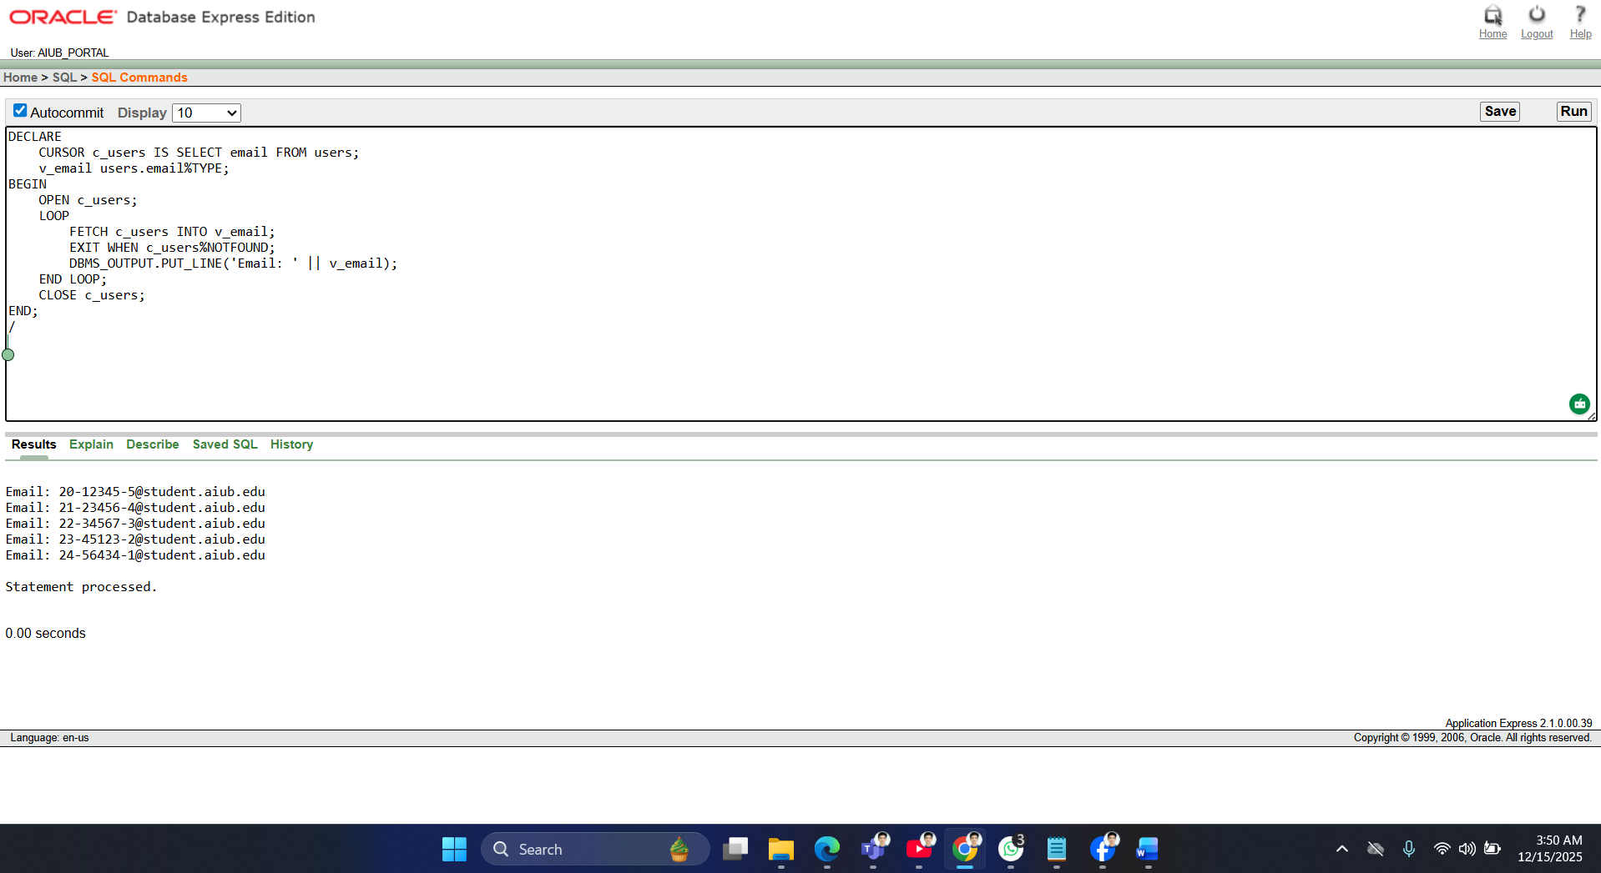

Cursor 2: Count users by program_level
DECLARE
CURSOR c_prog IS SELECT program_level, COUNT(*) AS cnt FROM users GROUP BY program_level;
v_prog c_prog%ROWTYPE;
BEGIN
OPEN c_prog;
LOOP
FETCH c_prog INTO v_prog;
EXIT WHEN c_prog%NOTFOUND;
DBMS_OUTPUT.PUT_LINE(v_prog.program_level || ': ' || v_prog.cnt);
END LOOP;
CLOSE c_prog;
END;
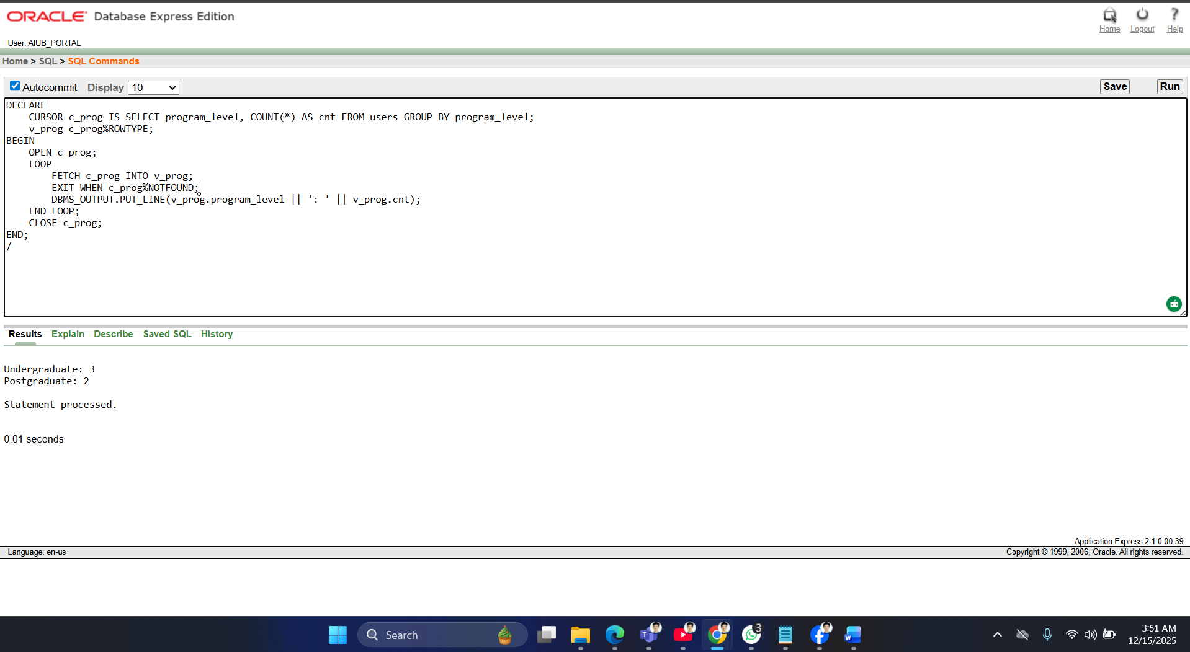
2 Cursor-Based Record
Example 1: Cursor with record
DECLARE
CURSOR c_users IS SELECT full_name, email FROM users;
v_user c_users%ROWTYPE;
BEGIN
OPEN c_users;
LOOP
FETCH c_users INTO v_user;
EXIT WHEN c_users%NOTFOUND;
DBMS_OUTPUT.PUT_LINE('Name: ' || v_user.full_name || ', Email: ' || v_user.email);
END LOOP;
CLOSE c_users;
END;
/
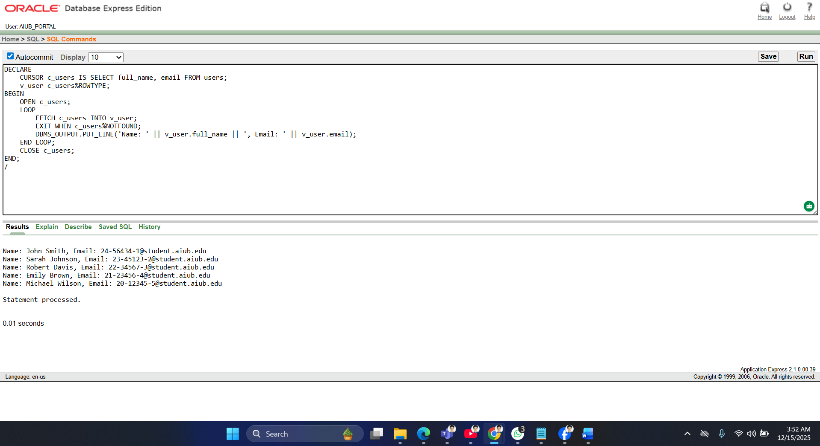
Example 2: Cursor with parameter
DECLARE
CURSOR c_students(p_dept VARCHAR2) IS SELECT full_name FROM users WHERE department = p_dept;
v_user c_students%ROWTYPE;
BEGIN
OPEN c_students('CSE');
LOOP
FETCH c_students INTO v_user;
EXIT WHEN c_students%NOTFOUND;
DBMS_OUTPUT.PUT_LINE('CSE Student: ' || v_user.full_name);
END LOOP;
CLOSE c_students;
END;
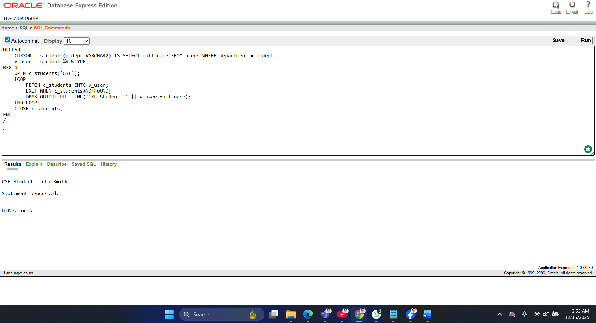
2 Row-Level Trigger
Trigger 1: Before insert, set profile_completed = 0
CREATE OR REPLACE TRIGGER trg_before_insert_users
BEFORE INSERT ON users
FOR EACH ROW
BEGIN
:NEW.profile_completed := 0;
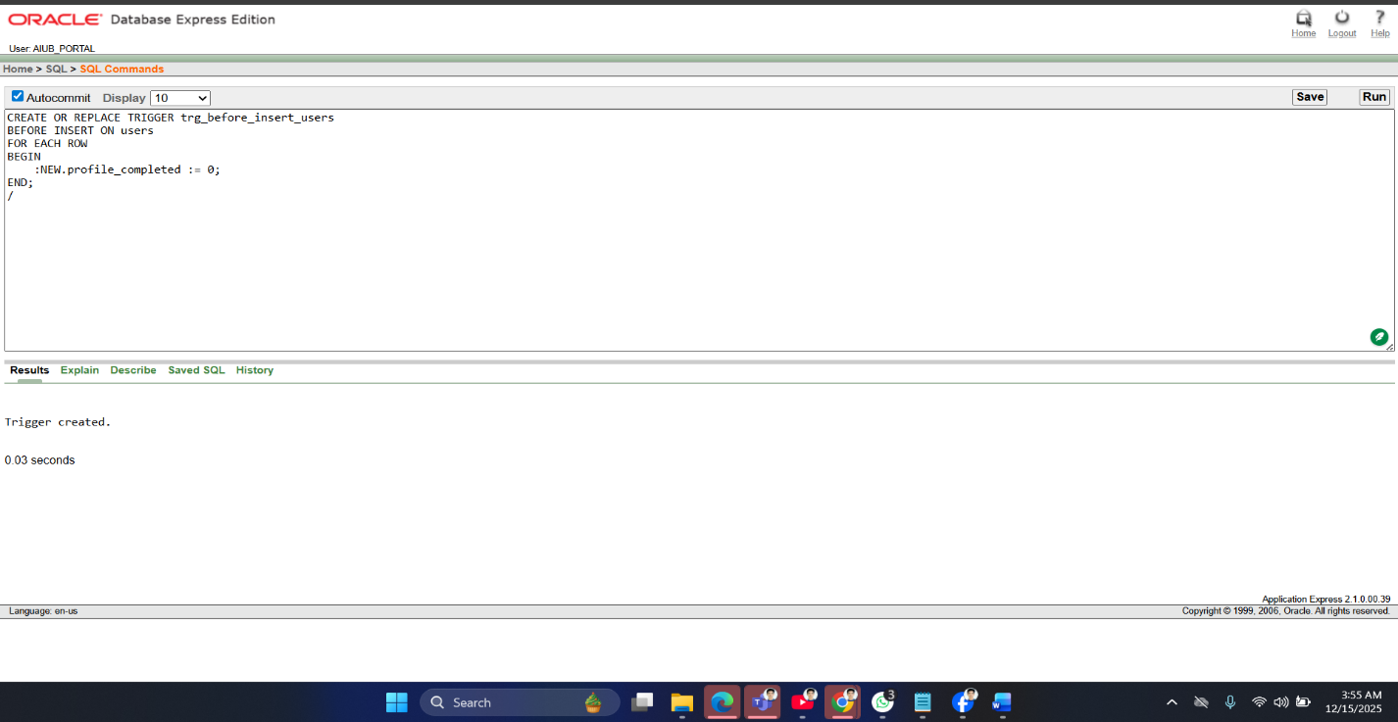
END;

Trigger 2: Before update, increment name_edit_count
CREATE OR REPLACE TRIGGER trg_before_update_name
BEFORE UPDATE OF full_name ON users
FOR EACH ROW
BEGIN
:NEW.name_edit_count := :OLD.name_edit_count + 1;
END;
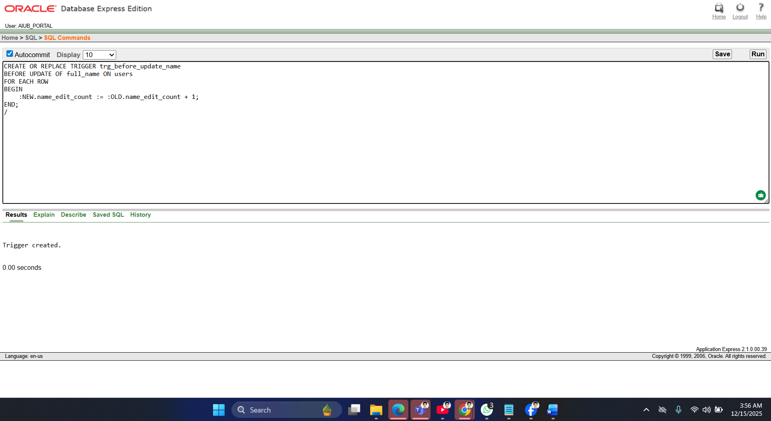
2Statement-Level Trigger
Trigger 1: After insert on users, log message
CREATE OR REPLACE TRIGGER trg_after_insert_users
AFTER INSERT ON users
BEGIN
DBMS_OUTPUT.PUT_LINE('A new user has been inserted.');
END;

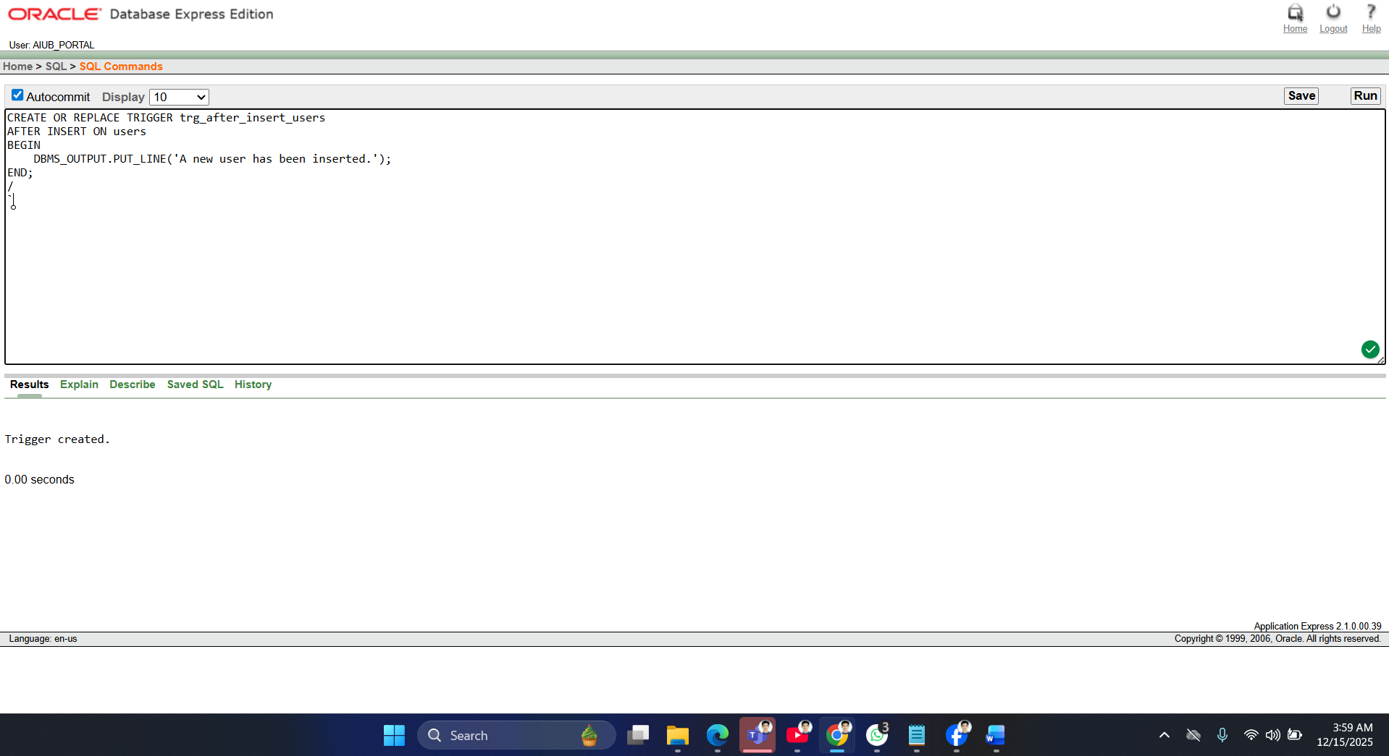
Trigger 2: After delete on users, log message
CREATE OR REPLACE TRIGGER trg_after_delete_users
AFTER DELETE ON users
BEGIN
DBMS_OUTPUT.PUT_LINE('A user has been deleted.');
END;
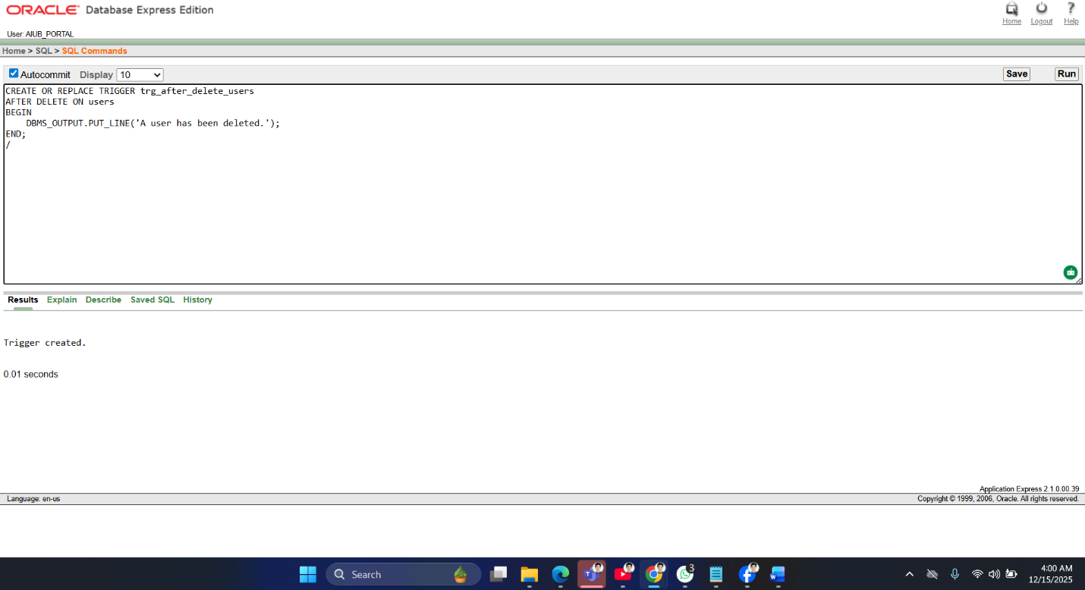

2 Package
1.CREATE OR REPLACE PACKAGE pkg_users IS
PROCEDURE print_user(p_id NUMBER);
FUNCTION get_user_email(p_id NUMBER) RETURN VARCHAR2;
END pkg_users;
/
Package Body
CREATE OR REPLACE PACKAGE BODY pkg_users IS

PROCEDURE print_user(p_id NUMBER) IS
v_name VARCHAR2(100);
BEGIN
SELECT full_name INTO v_name FROM users WHERE id = p_id;
DBMS_OUTPUT.PUT_LINE('User Name: ' || v_name);
END print_user;

FUNCTION get_user_email(p_id NUMBER) RETURN VARCHAR2 IS
v_email VARCHAR2(100);
BEGIN
SELECT email INTO v_email FROM users WHERE id = p_id;
RETURN v_email;
END get_user_email;

END pkg_users;
/
Test Package
BEGIN
pkg_users.print_user(1);
DBMS_OUTPUT.PUT_LINE('Email: ' || pkg_users.get_user_email(1));
END;
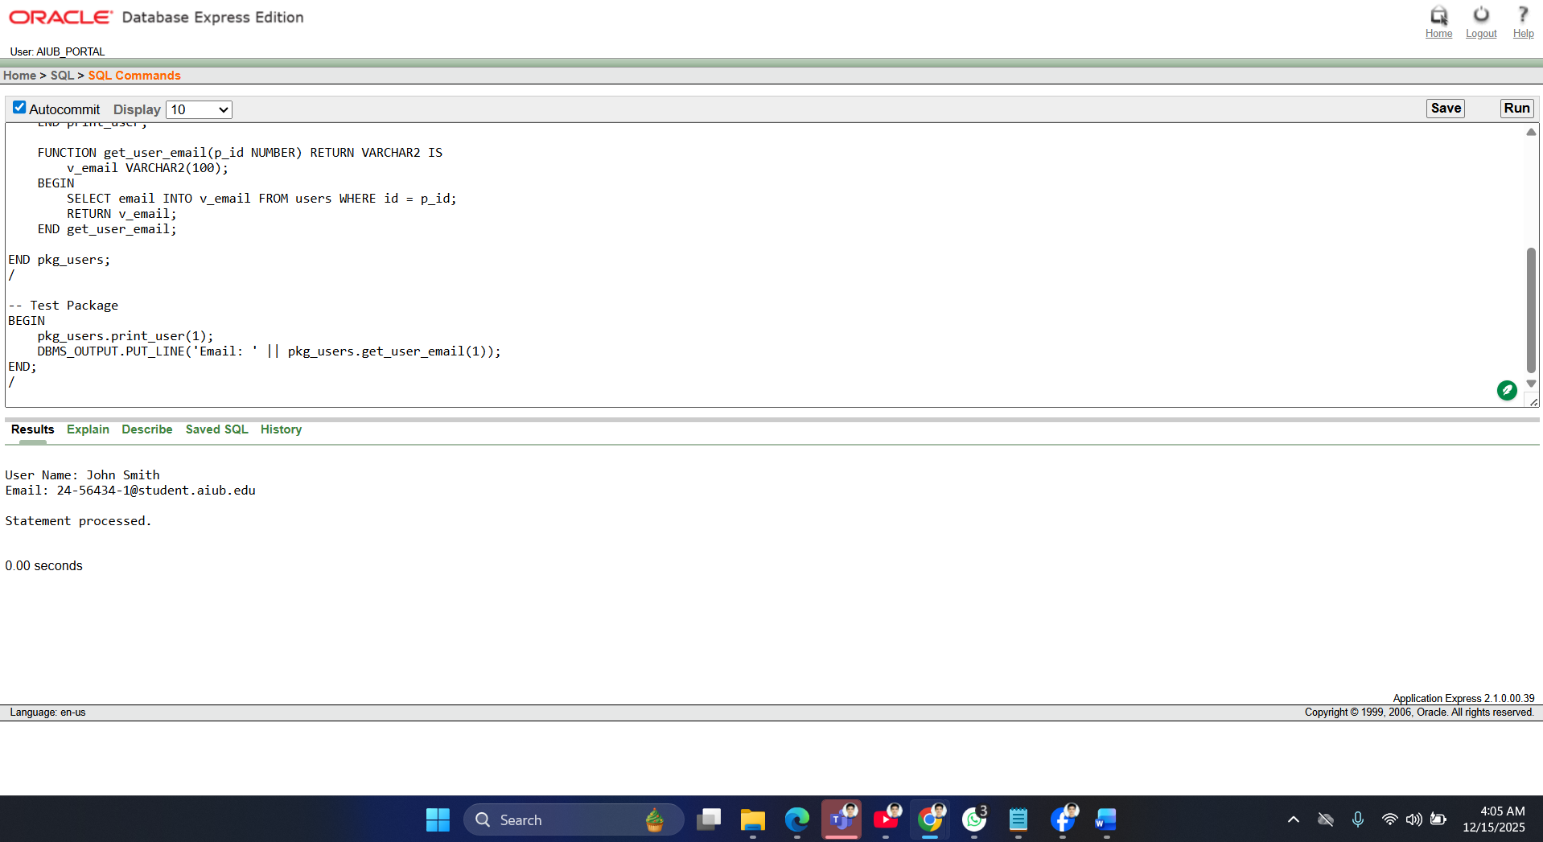

2. CREATE OR REPLACE PACKAGE pkg_users_info IS
PROCEDURE print_user_department(p_id NUMBER);
FUNCTION get_user_phone(p_id NUMBER) RETURN VARCHAR2;
END pkg_users_info;
/
CREATE OR REPLACE PACKAGE BODY pkg_users_info IS
PROCEDURE print_user_department(p_id NUMBER) IS
v_dept VARCHAR2(50);
BEGIN
SELECT department INTO v_dept FROM users WHERE id = p_id;
DBMS_OUTPUT.PUT_LINE('User Department: ' || v_dept);
END print_user_department;
FUNCTION get_user_phone(p_id NUMBER) RETURN VARCHAR2 IS
v_phone VARCHAR2(20);
BEGIN
SELECT phone_number INTO v_phone FROM users WHERE id = p_id;
RETURN v_phone;
END get_user_phone;

END pkg_users_info;
/
BEGIN
pkg_users_info.print_user_department(2);
DBMS_OUTPUT.PUT_LINE('Phone: ' || pkg_users_info.get_user_phone(2));
END;
/
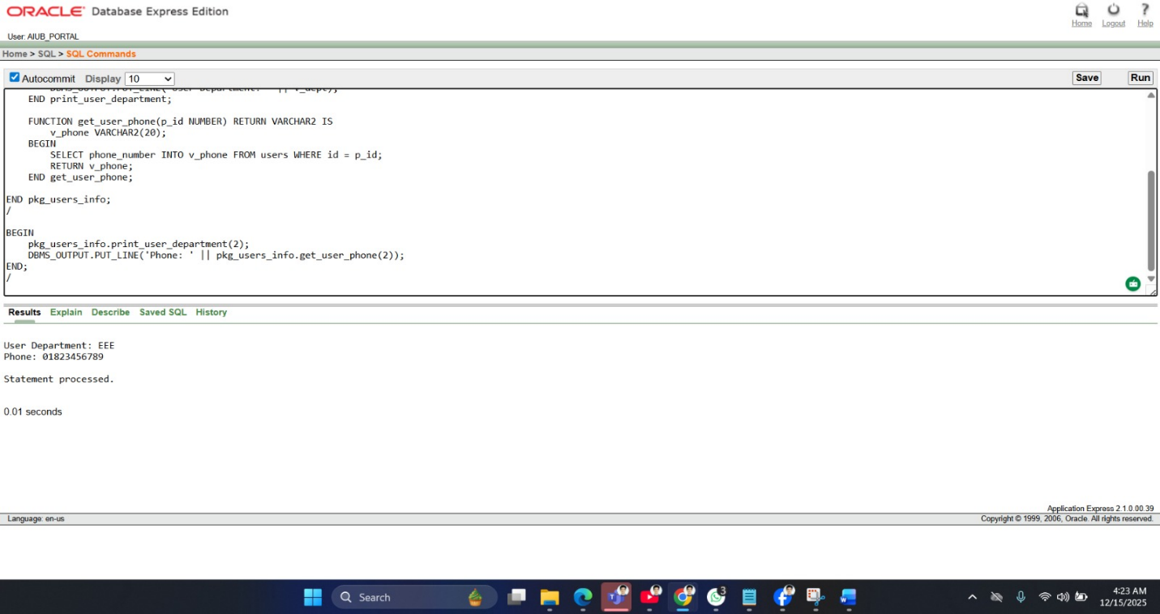

Conclusion
The AIUB Sports Portal was created to make sports management at American International University–Bangladesh easier and more organized. It successfully replaces the old manual registration system with a digital platform where students can log in securely, manage their profiles, view tournaments, and register for games online. At the same time, administrators can create tournaments, add games, and manage registrations from one place. This system reduces paperwork, saves time, and helps avoid common mistakes. The portal uses a well-structured database and secure login system to keep data accurate and safe. Overall, the project shows how a simple and well-designed web application can improve the management of university sports activities. In the future, the system can be improved by adding features such as online payment, email or SMS notifications, and match schedules. Live score updates, team management, and result tracking can also be included. Making the portal mobile-friendly or developing a mobile app would make it more convenient for users. With these improvements, the AIUB Sports Portal can become a more powerful and complete sports management system for AIUB.

